# ­­Graph Data Modeling course notes and links-

Course Introduction: <https://graphacademy.neo4j.com/courses/modeling-fundamentals/>

Video Introduction: <https://youtu.be/NrLMzcDtraE>

# Module 1: Getting Started

## **Module Overview**

In this module, you will learn about:

* What graph data modeling is.
* How domain knowledge is important for modeling.
* The difference between a graph data model and an instance model.

# What is Graph Data Modeling?

Youtube video: <https://youtu.be/UVx9ih3NEYQ>

Transcript-

## **Why model?**

If you use a Neo4j graph to support part or all of your application, you must collaboratively work with your stakeholders to design a graph that will:

* Answer the key use cases for the application.
* Provide the best Cypher statement performance for the key use cases.

### **Components of a Neo4j graph**

The Neo4j components that are used to define the graph data model are:

* Nodes
* Labels
* Relationships
* Properties

### **Data modeling process**

Here are the steps to create a graph data model:

1. Understand the domain and define specific use cases (questions) for the application.
2. Develop the initial graph data model:
   1. Model the nodes (entities).
   2. Model the relationships between nodes.
3. Test the use cases against the initial data model.
4. Create the graph (instance model) with test data using Cypher.
5. Test the use cases, including performance against the graph.
6. Refactor (improve) the graph data model due to a change in the key use cases or for performance reasons.
7. Implement the refactoring on the graph and retest using Cypher.

Graph data modeling is an iterative process. Your initial graph data model is a starting point, but as you learn more about the use cases or if the use cases change, the initial graph data model will need to change. In addition, you may find that especially when the graph scales, you will need to modify the graph (**refactor**) to achieve the best performance for your key use cases.

Refactoring is **very common** in the development process. A Neo4j graph has an optional schema which is quite flexible, unlike the schema in an RDBMS. A Cypher developer can easily modify the graph to represent an improved data model.

### **Main Points-**

1. The 4 elements to understand before graph modeling- Nodes, Labels, Relationships, Properties
2. The term we use for evolving a data model is Refactoring. In order to optimize your graph model for specific use cases you must Refactor it.

# The Domain

Youtube video: <https://youtu.be/dZUMBKc9XVM>

Transcript-

## **Understanding the domain for your application**

Before you begin the data modeling process you must:

* Identify the stakeholders and developers of the application.
* With the stakeholders and developers:
  + Describe the application in detail.
  + Identify the users of the application (people, systems).
  + Agree upon the use cases for the application.
  + Rank the importance of the use cases.

### **Movie domain**

In the course, [**Neo4j Fundamentals**](https://graphacademy.neo4j.com/courses/neo4j-fundamentals/), you were introduced to a "starter" movie graph.

The domain includes movies, people who acted or directed movies, and users who rated movies. What makes this domain interesting are the connections or relationships between nodes in the graph.

### **Use cases**

Most use cases for an application can be enumerated by a comprehensive list of questions. The use cases help to define how the application will behave at runtime.

Here are the use cases you will be working with to develop the initial graph data model:

1. What people acted in a movie?
2. What person directed a movie?
3. What movies did a person act in?
4. How many users rated a movie?
5. Who was the youngest person to act in a movie?
6. What role did a person play in a movie?
7. What is the highest rated movie in a particular year according to imDB?
8. What drama movies did an actor act in?
9. What users gave a movie a rating of 5?

In our domain, we want to differentiate a person who acted in or directed a movie and a user or reviewer who rated a movie. We have much more information about people such as their birth date, their tmdbId etc. Users who rated movies will just be named or identified.

Stakeholders can prepare for graph data modeling by doing the following:

* Describe the domain in detail.
* Identify the systems and users of the application.
* Enumerate the use cases of the application.

# Purpose of the Model

Youtube video: <https://youtu.be/0rutKWQloZg>

Transcript-

## **Types of models**

When performing the graph data modeling process for an application, you will need at least two types of models:

* Data model
* Instance model

### **Data model**

The data model describes the labels, relationships, and properties for the graph. It does not have specific data that will be created in the graph.

Here is an example of a data model:

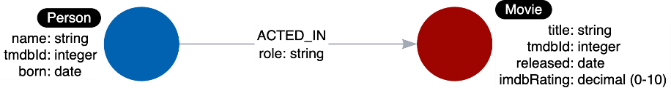

There is nothing that uniquely identifies a node with a given label. A graph data model, however is important because it defines the names that will be used for labels, relationship types, and properties when the graph is created and used by the application.

### **Style guidelines for modeling**

As you begin the graph data modeling process, it is important that you agree upon how labels, relationship types, and property keys are named. Labels, relationship types, and property keys are case-sensitive, unlike Cypher keywords which are case-insensitive.

A Neo4j best practice is to use the following when you name the elements of the graph, but you are free to use any convention for your application.

* A label is a single identifier that begins with a capital letter and can be [**CamelCase**](https://en.wikipedia.org/wiki/Camel_case).
  + Examples: Person, Company, GitHubRepo
* A relationship type is a single identifier that is in all capital letters with the underscore character.
  + Examples: FOLLOWS, MARRIED_TO
* A property key for a node or a relationship is a single identifier that begins with a lower-case letter and can be [**camelCase**](https://en.wikipedia.org/wiki/Camel_case).
  + Examples: deptId, firstName

**Note**: Property key names need not be unique. For example, a Person node and a Movie node, each can have the property key of tmdbId.

### **Instance model**

An important part of the graph data modeling process is to test the model against the use cases. To do this, you need to have a set of sample data that you can use to see if the use cases can be answered with the model.

Here is an example of an instance model:

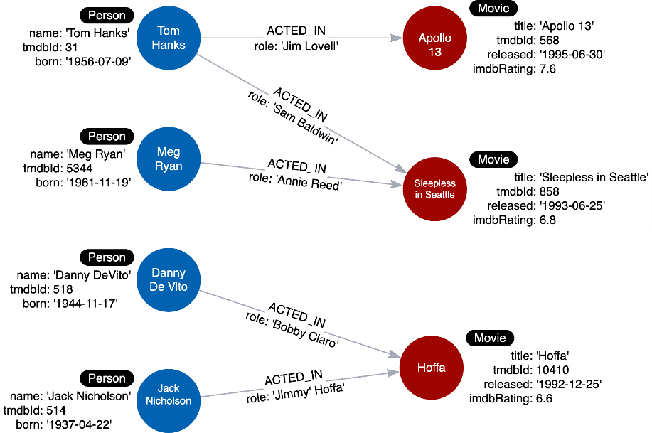

In this instance model, we have created some instances of Person and Movie nodes, as well as their relationships. Having this type of instance model will help us to test our use cases.

# Module 2: Modeling Nodes

**Module Overview**

In this module, you will learn about:

* Identifying the entities from your use cases.
* Creating nodes in the graph in support of the data model.

# Modeling Nodes

Youtube video: <https://youtu.be/KULZmqpuDqo>

Transcript-

## **Defining labels**

Entities are the dominant nouns in your application use cases:

1. What **ingredients** are used in a **recipe**?
2. Who is married to this **person**?

The entities of your use cases will be the labeled nodes in the graph data model.

In the Movie domain, we use the **nouns** in our use cases to define the labels, for example:

1. What **people** acted in a **movie**?
2. What **person** directed a **movie**?
3. What **movies** did a **person** act in?

Here are some of the labeled nodes that we will start with.

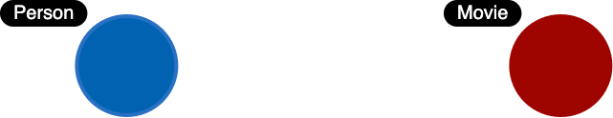

Notice here that we use CamelCase for the names for labels.

### **Node properties**

Node properties are used to:

* Uniquely identify a node.
* Answer specific details of the use cases for the application.
* Return data.

For example, in a Cypher statement, properties are used to:

* Anchor (where to begin the query).
  + MATCH (p:Person {name: 'Tom Hanks'})-[:ACTED_IN]-(m:Movie) RETURN m
* Traverse the graph (navigation).
  + MATCH (p:Person)-[:ACTED_IN]-(m:Movie {title: 'Apollo 13'})-[:RATED]-(u:User) RETURN p,u
* Return data from the query.
  + MATCH (p:Person {name: 'Tom Hanks'})-[:ACTED_IN]-(m:Movie) RETURN m.title, m.released

### **Unique identifiers in the Movie graph**

In the Movie graph, we use the following properties to uniquely identify our nodes:

* Person.tmdbId
* Movie.tmdbId

### **Properties for nodes**

In addition to the tmdbId that is used to uniquely identify a node, we must revisit the use cases to determine the types of data a node must hold.

Here is a list of our use cases specific to Person and Movie nodes that we will focus on. These use cases inform us about the data we need in Movie and Person nodes.

| **Use case** | **Steps required** |
| --- | --- |
| 1: What people acted in a movie? | 1. Retrieve a movie by its **title**. 2. Return the **names** of the actors. |
| 2: What person directed a movie? | 1. Retrieve a movie by its **title**. 2. Return the **name** of the director. |
| 3: What movies did a person act in? | 1. Retrieve a person by their **name**. 2. Return the **titles** of the movies. |
| 5: Who was the youngest person to act in a movie? | 1. Retrieve a movie by its **title**. 2. Evaluate the **ages** of the actors. 3. Return the **name** of the actor. |
| 7: What is the highest rated movie in a particular year according to imDB? | 1. Retrieve all movies **released** in a particular year. 2. Evaluate the **imDB ratings**. 3. Return the movie **title**. |
| 8: What drama movies did an actor act in? | 1. Retrieve the actor by **name**. 2. Evaluate the **genres** for the movies the actor acted in. 3. Return the movie **titles**. |

Given the details of the steps of these use cases, here are the properties we will define for the Movie nodes:

* Movie.title (string)
* Movie.released (date)
* Movie.imdbRating (decimal between 0-10)
* Movie.genres (list of strings)

Here are the properties we will define for the Person nodes:

* Person.name (string)
* Person.born (date)
* Person.died (date)

Note: The died property will be optional.

Here is the initial data model:

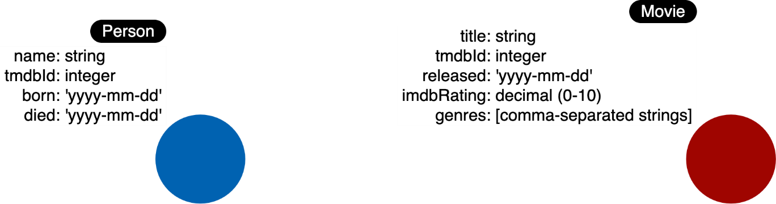

And here is the initial instance model you will be creating:

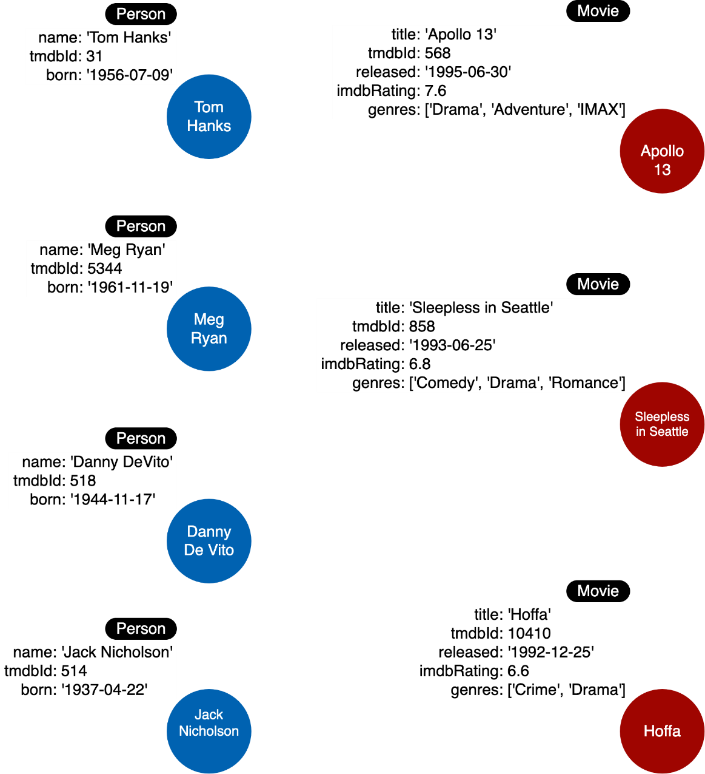

### **Main Points-**

* 1. Nouns represent the things or entities in your use cases and they define the labels for the data model.
  2. Node properties can be used for:

Uniquely identifying a node.

Answering specific details of the use cases.

Returning data.

### **Creating nodes**

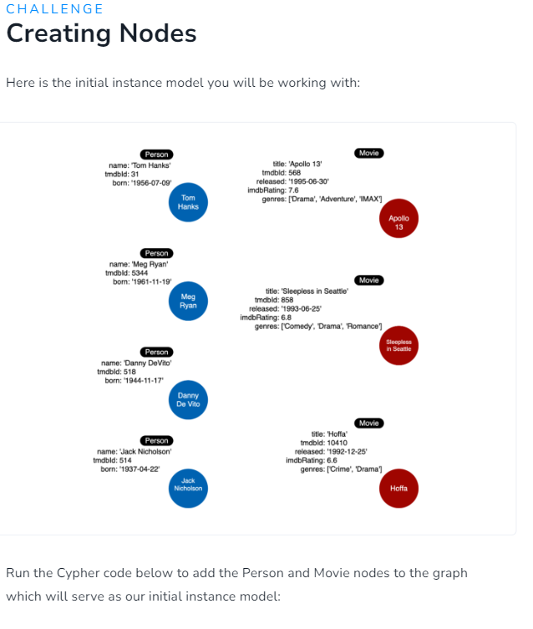

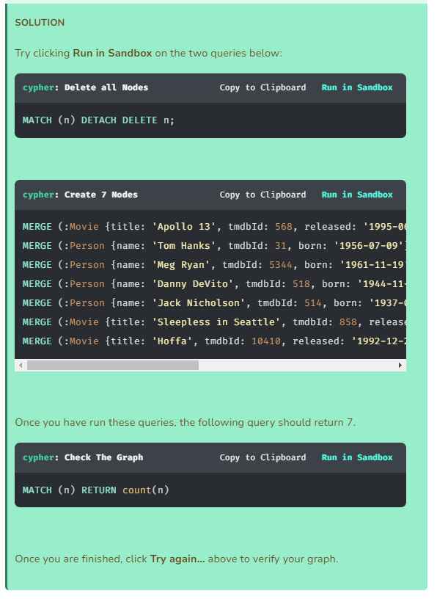

### **Creating more nodes**

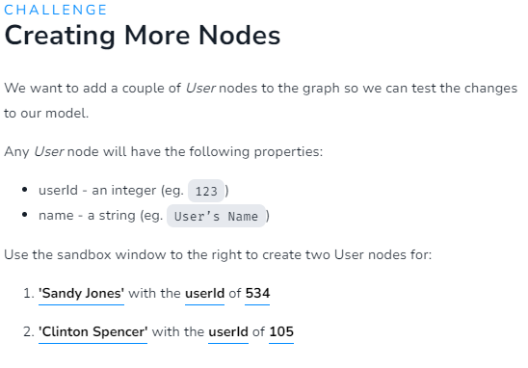

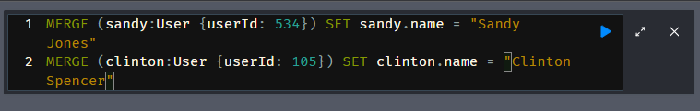

**Module 3: Modeling Relationships**

**Module Overview**

In this module, you will learn about:

* Identifying the relationships from your use cases.
* Creating relationships in the graph to support the data model.

# Modeling Relationships

Youtube video: <https://youtu.be/zJrI7QAzzGQ>

Transcript-

## **Relationships are connections between entities**

Connections are the **verbs** in your use cases:

* What ingredients are **used** in a recipe?
* Who is **married** to this person?

At a glance, connections are straightforward things, but their micro- and macro-design are arguably the most critical factors in graph performance. Using “connections are verbs” is a fine shorthand to get started, but there are other important considerations that you will learn about later in this course.

### **Naming relationships**

Choosing good names (types) for the relationships in the graph is important. Relationship types need to be something that is intuitive to stakeholders and developers alike. Relationship types cannot be confused with an entity name.

So in our example use cases, we could define these relationship types:

* USES
* MARRIED

Note here that we use the Neo4j best practice of all capital letters/underscore characters for the name of the relationship.

### **Relationship direction**

When you create a relationship in Neo4j, a direction must either be specified explicitly or inferred by the left-to-right direction in the pattern specified. At runtime, during a query, direction is typically not required.

In our example use cases shown above, the **USES** relationship must be created to go from a Recipe node to an Ingredient node.

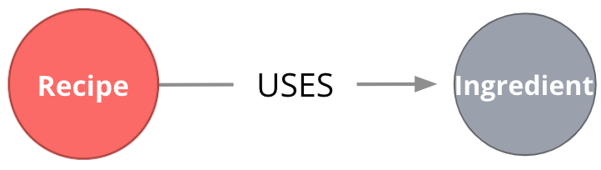

The **MARRIED** relationship could be created to start in either node since this type of relationship is symmetric.

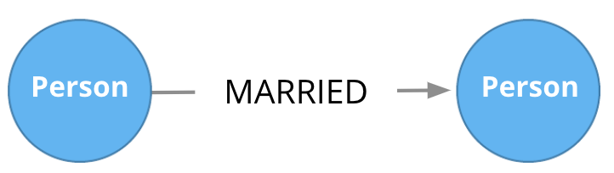

A relationship is typically between 2 different nodes, but it can also be to the same node.

### **Fanout**

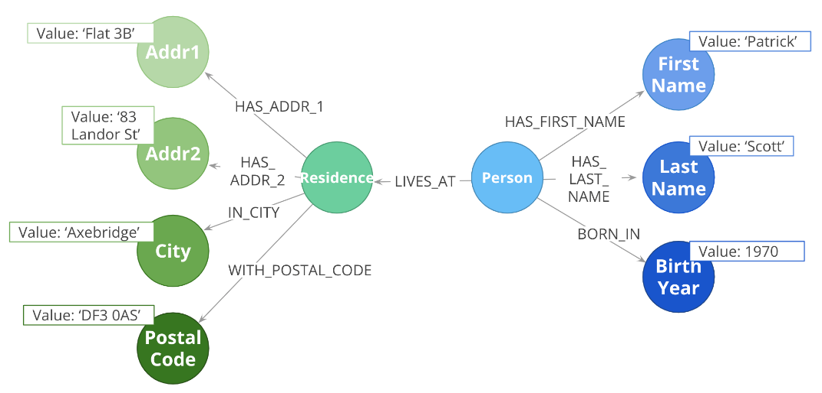

Here, we have entities (Person, Residence) represented not as a single node, but as a network or linked nodes.

This is an extreme example of fanout, and is almost certainly overkill for any real-life solution, but some amount of fanout can be very useful.

For example, splitting last names onto separate nodes helps answer the question, “Who has the last name Scott?”. Similarly, having cities as separate nodes assists with the question, “Who lives in the same city as Patrick Scott?”.

The main risk about fanout is that it can lead to very dense nodes, or supernodes. These are nodes that have hundreds of thousands of incoming or outgoing relationships Supernodes need to be handled carefully.

### **Relationships in the Movie graph**

Now let’s look at identifying the relationships for these use cases:

* What people **acted** in a movie?
* What person **directed** a movie?
* What movies did a person **act** in?

Given these use cases, we name the relationships:

* ACTED_IN
* DIRECTED

Furthermore, both of these relationship types start at Person nodes and end in Movie nodes.

Here is the supporting graph data model:

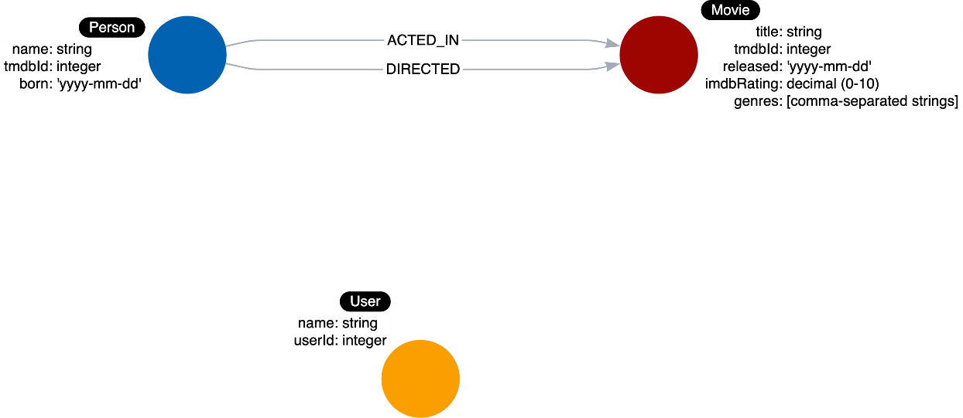

And here is the instance model to support this graph data model:

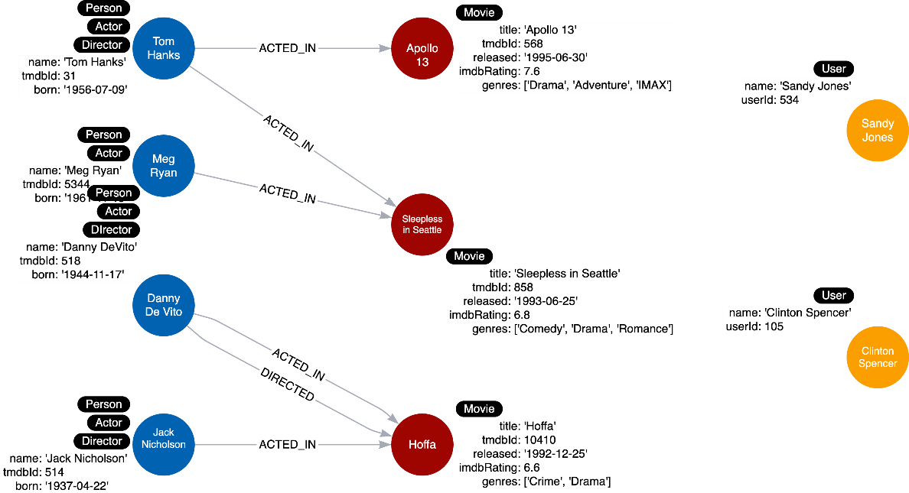

Tom Hanks acted in two movies. Meg Ryan and Jack Nicholson each acted in one movie. Danny DeVito both acted in and directed the same movie. Exploring relationships with this instance model we see that the movie Apollo 13 has a single actor in the graph, but the other two movies have two actors each.

### **Properties for relationships**

Properties for a relationship are used to enrich how two nodes are related. When you define a property for a relationship, it is because your use cases ask a specific question about how two nodes are related, not just that they are related.

For example, we saw in the Neo4j Fundamentals course that properties can be added to a relationship to further describe it.

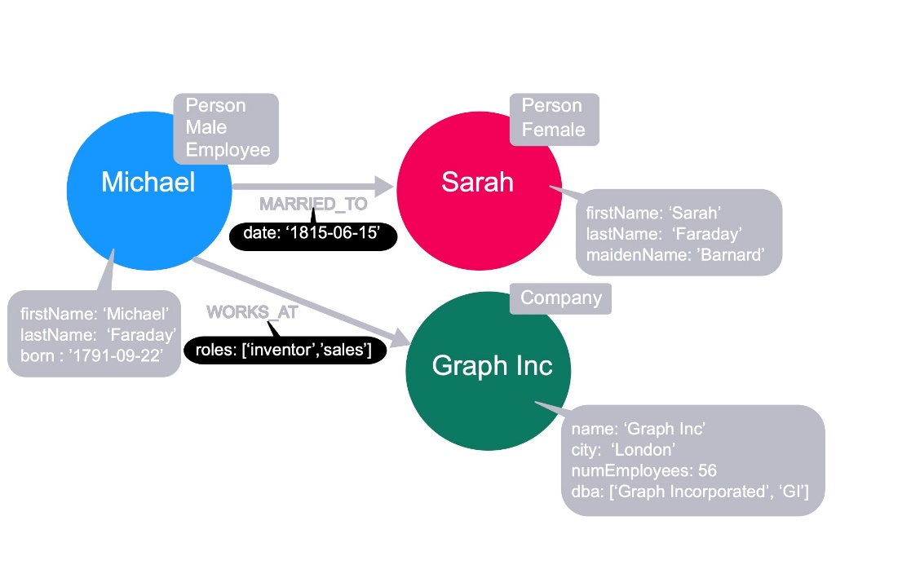

Here we see that we have a date property on the MARRIED relationship to further describe the relationship between Michael and Sarah. Additionally, we have a roles property on the WORKS_AT relationship to describe the roles that Michael has or had when he worked at Graph Inc.

These properties are specific to the relationship between two nodes.

### **Relationship properties in the Movie graph**

Just like you analyze the use cases for naming labels, relationship types, and node properties, you use the use cases to come up with properties for relationships.

Here is a use case:

1. **What role did a person play in a movie?**

The runtime operations for this use case are:

1. Retrieve the name of the person.
2. Follow the ACTED_IN relationships to movies.
3. Filter the movie by its title.
4. Return the **role** from the ACTED_IN relationship between the two nodes.

We know that the role for a particular ACTED_IN relationship will be necessary for this use case. So we add the role property to this relationship. Here is the data model:

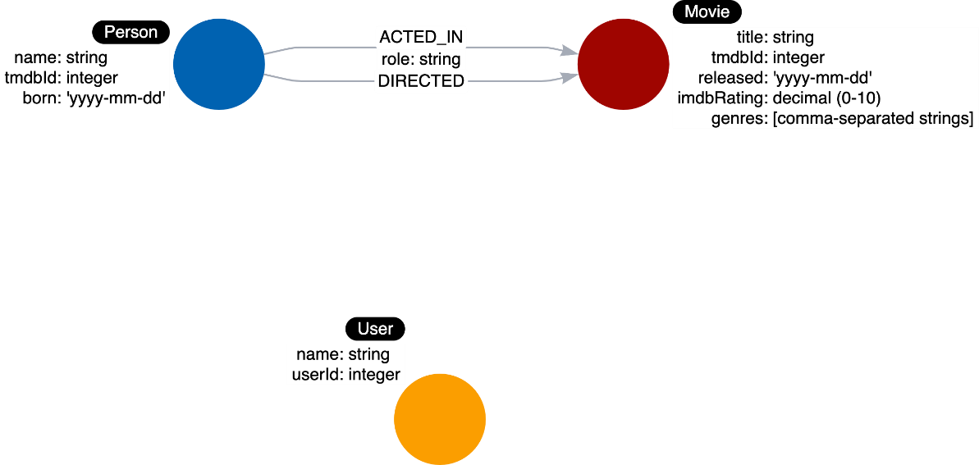

And here is the instance model you will be creating:

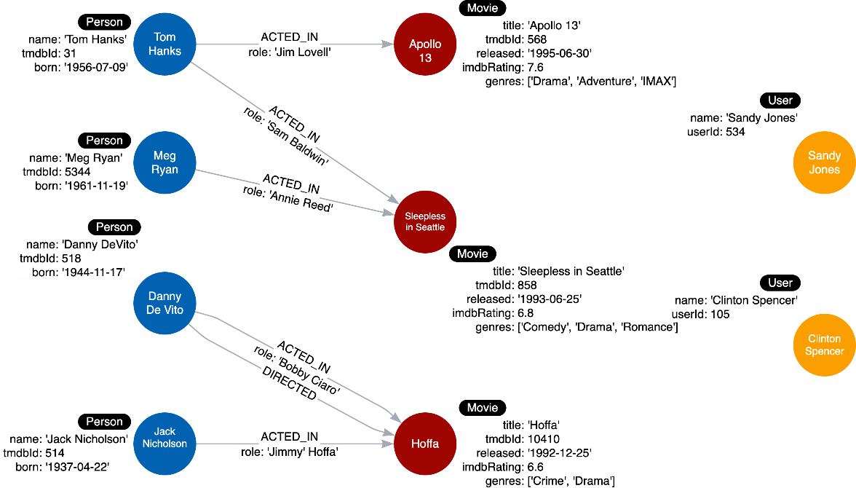

Each ACTED_IN relationship here has a different value for the role property.

### **Main Points-**

* 1. Verbs in your use cases are used to represent the connections between entities in the graph.
  2. You must specify the following when you define a relationship in the graph:

The starting node (with label) for the relationship.

The ending node (with label) for the relationship.

The name (type) for the relationship.

### **Creating Initial Relationships**

Here is the instance model you will be creating:

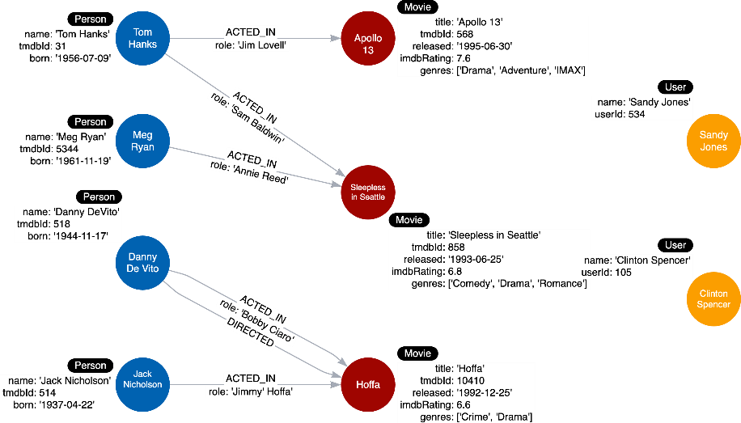

Each ACTED_IN relationship here has a different value for the role property.

Run this Cypher code to add the ACTED_IN and DIRECTED relationships to the graph:

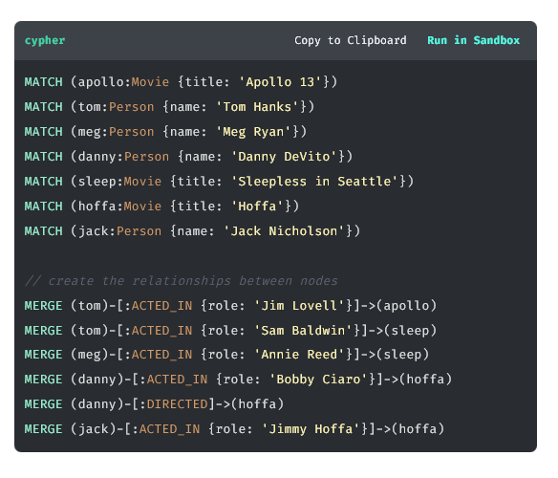

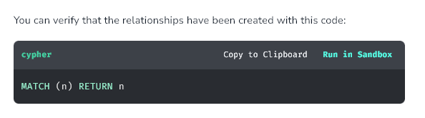

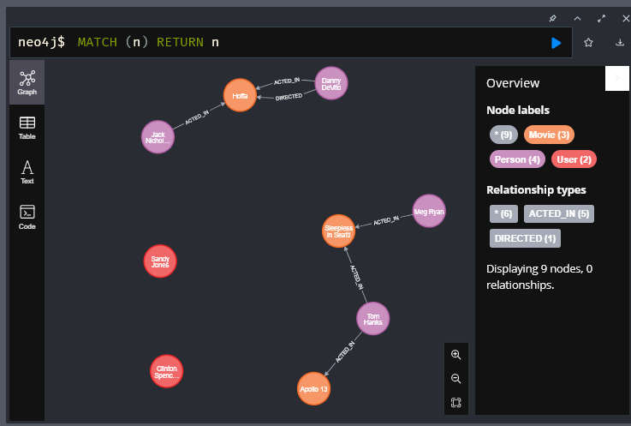

### **Creating More Relationships**

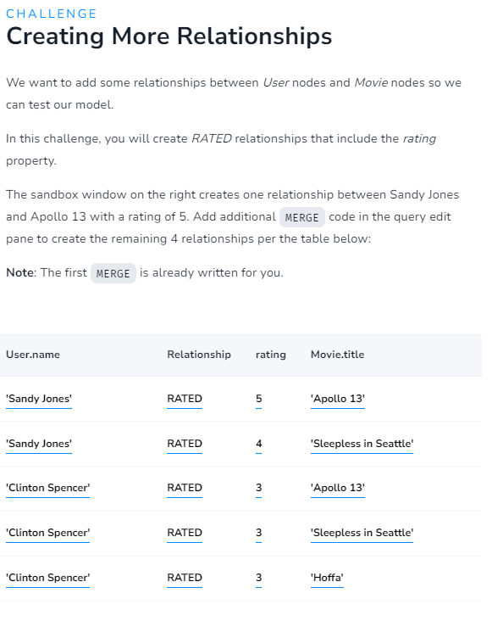

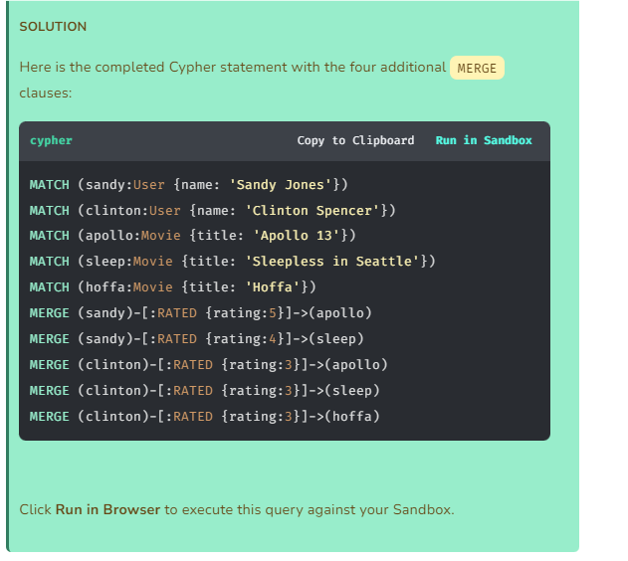

**Module 4: Testing the Model**

**Module Overview**

In this module, you will test that the graph can be used to test the use cases of the model.

# Testing

Youtube video: <https://youtu.be/sTFphw55FIY>

Transcript-

## Why test?

Thus far you have seen that you design the data model on paper, whiteboard, or with a tool like [**Arrows app**](https://arrows.app/). You use the use cases to design the data model that includes labels for nodes, relationship types and direction, and properties for the nodes and relationships.

You have also populated the graph to implement the data model with a small set of test data. To ensure that the graph can satisfy every use case, you must test the use cases against the graph.

### **Testing the data model**

Here is the instance model that should now be in our graph:

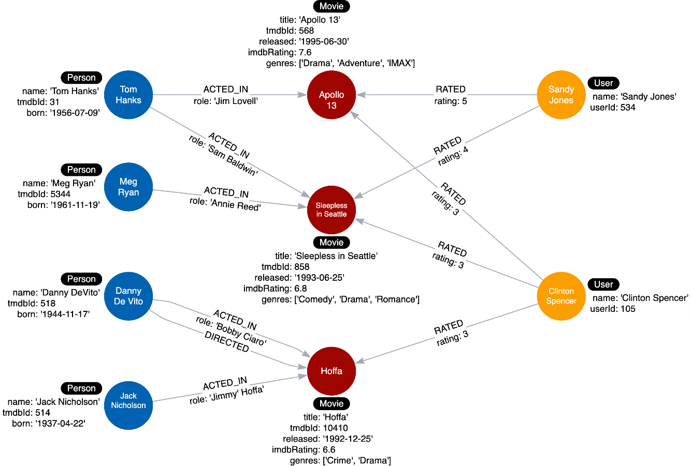

In the next challenge you will test each use case against the graph by executing Cypher queries.

Your testing will be to execute Cypher code against the instance model to verify that graph and the query support the use case.

For example, with our first use case:

**Use case #1: What people acted in a movie?**

You will execute this query where you specify the title of the movie:

**cypher**

MATCH (p:Person)-[:ACTED_IN]-(m:Movie)

WHERE m.title = 'Sleepless in Seattle'

RETURN p.name AS Actor

In the description of the use cases, you may even specify what the expected result should be.

### **More testing?**

As you go through the use cases, you may think of more data that you want to add to the graph to round out the testing.

The Cypher code used to test the use cases needs to be carefully reviewed for correctness. In addition, you must understand that if and when the graph is refactored (next module), the Cypher code for these use cases may need to be modified to improve performance.

The basic testing to ensure that the use cases can be answered by the data model is the first step of testing.

A really important factor with testing the graph is **scalability**. How will these queries perform if the graph has millions of nodes or relationships? This is where you need to work with the Cypher developers to test the performance of the queries when the graph grows.

### **Main Points-**

* 1. You may want to add more data to your graph to test that query results returned in a prompt manner.
  2. If results are not returned fast enough, you may want to test and modify any Cypher to improve performance.
  3. If results can not be obtained in a timely fashion, or your entire use case is not yet supported, you will need to refactor your data model.

### **Testing with Instance models-**

Here is the instance model that should now be in our graph:

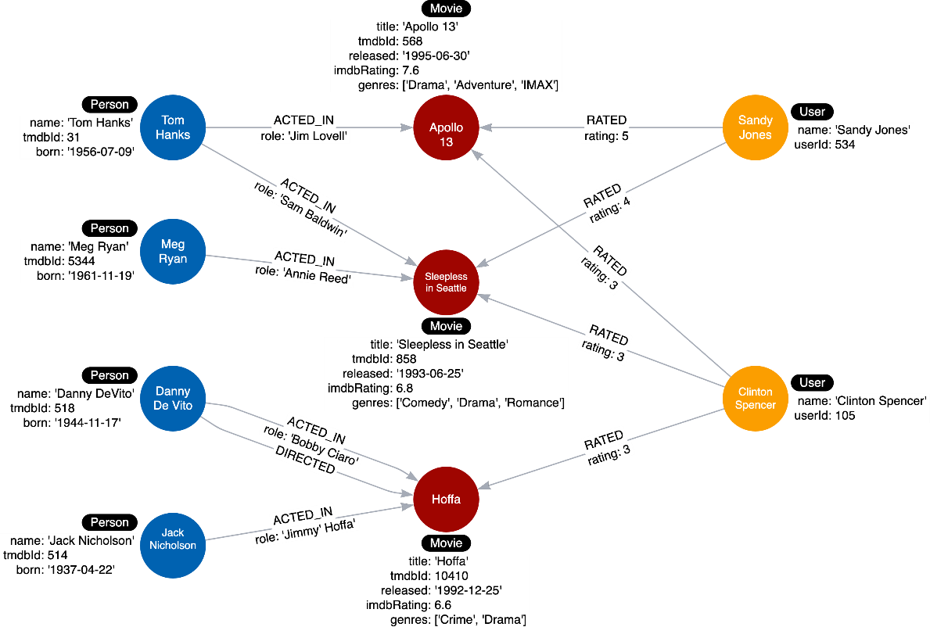

In this challenge, you will test each use case against the graph by executing Cypher queries. The query values will be specific to the data we know is in the graph, but you can imagine that a fully-populated graph would satisfy a broader range of query parameters.

Follow the instructions below to test each use case for our application.

## **Use case #1: What people acted in a movie?**

Run this Cypher code to test this use case using the movie, Sleepless in Seattle.

**cypher**

Copy to ClipboardRun in Sandbox

MATCH (p:Person)-[:ACTED_IN]-(m:Movie)

WHERE m.title = 'Sleepless in Seattle'

RETURN p.name AS Actor

It should return two names of actors, Tom Hanks, and Meg Ryan.

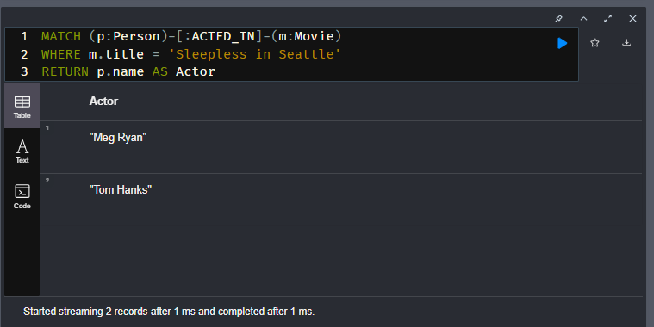

## **Use case #2: What person directed a movie?**

Run this Cypher code to test this use case using the movie, Hoffa.

**cypher**

Copy to ClipboardRun in Sandbox

MATCH (p:Person)-[:DIRECTED]-(m:Movie)

WHERE m.title = 'Hoffa'

RETURN p.name AS Director

It should return Danny DeVito.

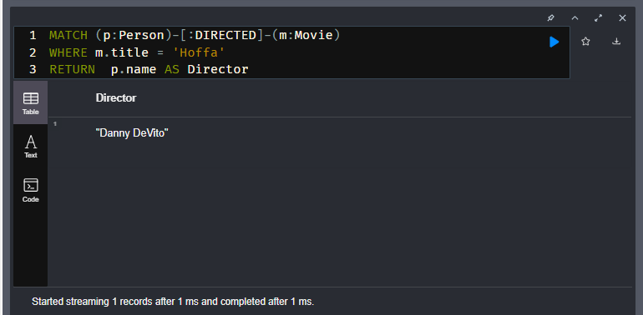

## **Use case #3: What movies did a person act in?**

Run this Cypher code to test this use case using the person, Tom Hanks.

**cypher**

Copy to ClipboardRun in Sandbox

MATCH (p:Person)-[:ACTED_IN]-(m:Movie)

WHERE p.name = 'Tom Hanks'

RETURN m.title AS Movie

It should return the movies Apollo 13 and Sleepless in Seattle.

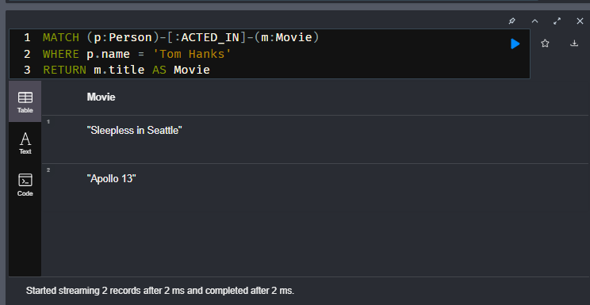

## **Use case #4: How many users rated a movie?**

Run this Cypher code to test this use case using the movie, Apollo 13.

**cypher**

Copy to ClipboardRun in Sandbox

MATCH (u:User)-[:RATED]-(m:Movie)

WHERE m.title = 'Apollo 13'

RETURN count(*) AS `Number of reviewers`

It should return 2.

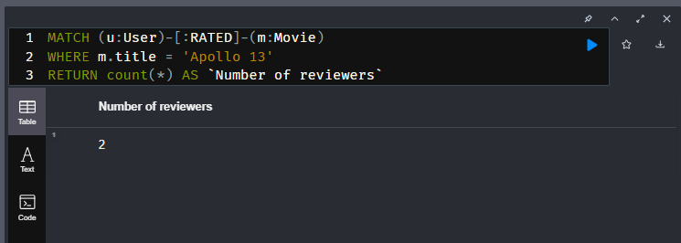

## **Use case #5: Who was the youngest person to act in a movie?**

Run this Cypher code to test this use case using the movie, Hoffa.

**cypher**

Copy to ClipboardRun in Sandbox

MATCH (p:Person)-[:ACTED_IN]-(m:Movie)

WHERE m.title = 'Hoffa'

RETURN p.name AS Actor, p.born as `Year Born` ORDER BY p.born DESC LIMIT 1

It should return Danny DeVito with his birth year.

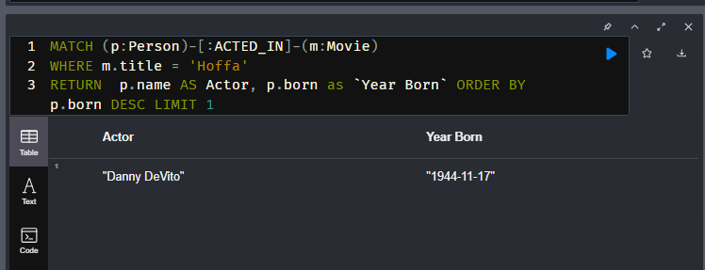

## **Use case #6: What role did a person play in a movie?**

Run this Cypher code to test this use case using the movie, Sleepless in Seattle and the person, Meg Ryan.

**cypher**

Copy to ClipboardRun in Sandbox

MATCH (p:Person)-[r:ACTED_IN]-(m:Movie)

WHERE m.title = 'Sleepless in Seattle' AND

p.name = 'Meg Ryan'

RETURN r.role AS Role

It should return Annie Reed.

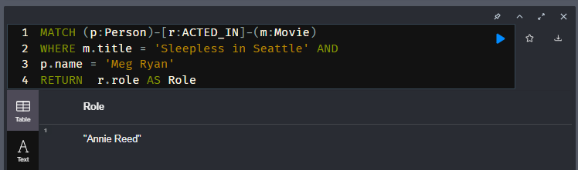

## **Use case #7: What is the highest rated movie in a particular year according to imDB?**

Run this Cypher code to test this use case using movies in the year 1995.

**cypher**

Copy to ClipboardRun in Sandbox

MATCH (m:Movie)

WHERE m.released STARTS WITH '1995'

RETURN m.title as Movie, m.imdbRating as Rating ORDER BY m.imdbRating DESC LIMIT 1

Our test data has only one movie released in 1995, but if you were to add another movie to the graph that was released in 1995, this query would be answered correctly. In this case, you must add more data to the graph to fully test this query.

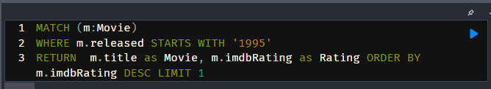

Run the Cypher code to add another Movie node and its director to the graph:

**cypher**

Copy to ClipboardRun in Sandbox

MERGE (casino:Movie {title: 'Casino', tmdbId: 524, released: '1995-11-22', imdbRating: 8.2, genres: ['Drama','Crime']})

MERGE (martin:Person {name: 'Martin Scorsese', tmdbId: 1032})

MERGE (martin)-[:DIRECTED]->(casino)

You can rerun the query above to test the use case and receive a different result.

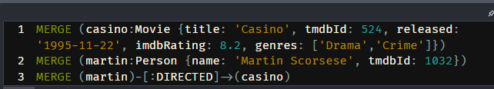

The new instance model for this graph is now:

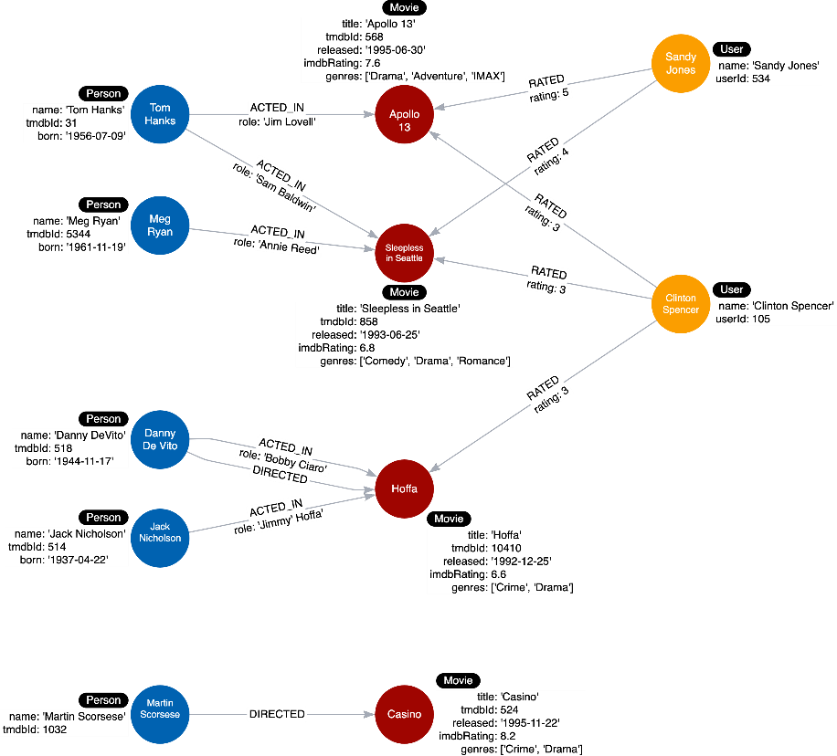

## **Use case #8: What drama movies did an actor act in?**

Run this Cypher code to test this use case using the person, Tom Hanks.

**cypher**

Copy to ClipboardRun in Sandbox

MATCH (p:Person)-[:ACTED_IN]-(m:Movie)

WHERE p.name = 'Tom Hanks' AND

'Drama' IN m.genres

RETURN m.title AS Movie

If you were to change 'Drama' to 'Comedy' in this query, it would return a different result.

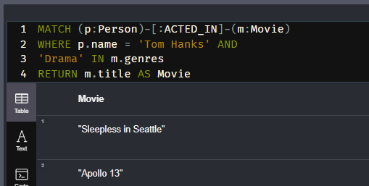

## **Use case #9: What users gave a movie a rating of 5?**

Run this Cypher code to test this use case using the movie, Apollo 13.

**cypher**

Copy to ClipboardRun in Sandbox

MATCH (u:User)-[r:RATED]-(m:Movie)

WHERE m.title = 'Apollo 13' AND

r.rating = 5

RETURN u.name as Reviewer

It should return Sandy Jones.

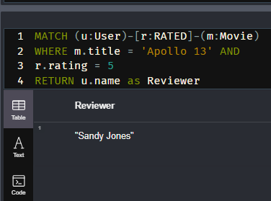

This query returns everything in the graph. Run this query and answer the following questions about the instance model:

**cypher**

Copy to ClipboardRun in Sandbox

MATCH (n) RETURN n

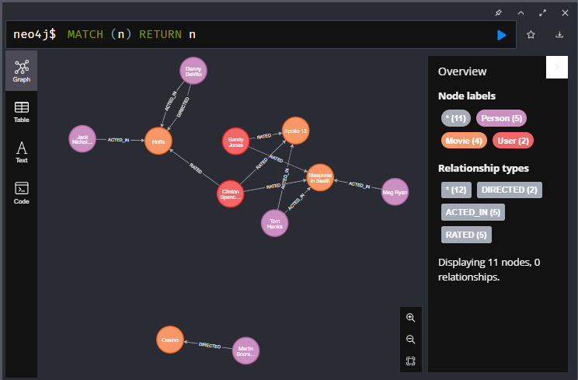

# Module 5: Refactoring the Graph

## **Module Overview**

In this module, you will learn about:

* Why we refactor a graph data model and graph.
* Adding labels to the data model.

# Refactoring

Youtube video: <https://youtu.be/GlEMK_J3_KM>

Transcript-

## **Why refactor?**

Refactoring is the process of changing the data model **and** the graph.

There are three reasons why you would refactor:

* The graph as modeled does not answer all of the use cases.
* A new use case has come up that you must account for in your data model.
* The Cypher for the use cases does not perform optimally, especially when the graph scales

### **Steps for refactoring**

To refactor a graph data model and a graph, you must:

1. Design the new data model.
2. Write Cypher code to transform the existing graph to implement the new data model.
3. Retest all use cases, possibly with updated Cypher code.

Basically

You may want to refactor if any of the use cases **cannot be answered**, or if another use case has been added. It it also important to ensure that the data model **scales effectively** and still provides data in a timely fashion.

As long as the data model stays the same, you **do not need to refactor the graph** specifically when updating or adding new data.

# Labels in the Graph

Youtube video: <https://youtu.be/sp4SjLiDnq8>

Transcript-

## **Labels at runtime**

Node labels serve as an anchor point for a query. By specifying a label, we are specifying a subset of one or more nodes with which to start a query. Using a label helps to reduce the amount of data that is retrieved.

For example:

MATCH (n) RETURN n returns all nodes in the graph.

MATCH (n:Person) RETURN n returns all Person nodes in the graph.

Your goal in modeling should be to reduce the size of the graph that is touched by a query.

In Cypher, you can produce a query plan that shows what operations occur during the query. This figure shows a query plan by the number of db hits for the query to retrieve all Person nodes:

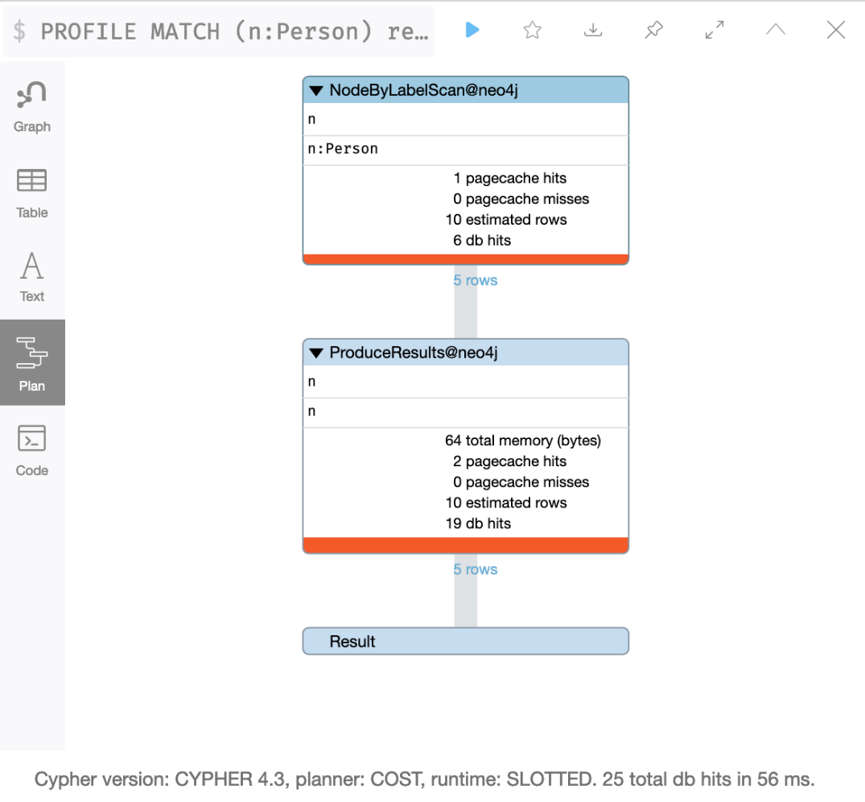

Later in this lesson you will learn how to produce a query plan.

If Person nodes also had a label which is the country that a person is from, then you could used this Cypher code to retrieve all people from the US:

MATCH (n:US) RETURN n returns all US nodes in the graph which happen to be Person nodes.

But having a label that is specific like this might be overkill, especially if the query could be:

MATCH (n:Person) WHERE n.country = 'US' RETURN n

In Cypher, you cannot parameterize labels so keeping the country as a property makes the Cypher code more flexible.

But if you have a strong use case for having multiple labels for a node, you should do so.

### **Do not overuse labels**

You should use labels wisely in your data model. They should be used if it will help with **most** of your use cases. A best practice is to limit the number of labels for a node to 4.

Here is an example of overuse of labels in the data model:

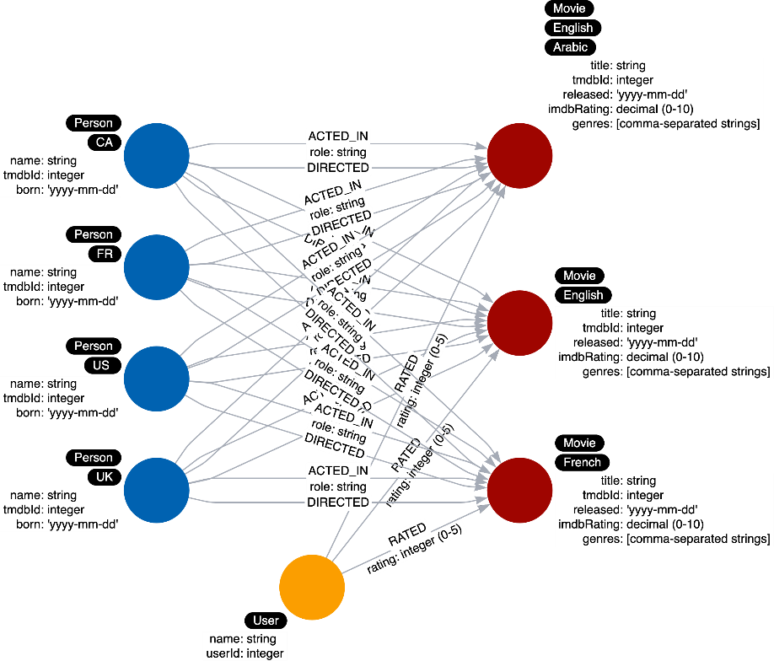

Here we see Person nodes that have a label representing the country that a Person is from like we described earlier.

In addition, we see multiple labels for Movie nodes. The label represents the languages available for a movie.

This is another similar scenario where you must decide if an important use case is related to the language of a movie. Again if the use of a property for a node will suffice, then it is best to not have the label.

### **New use case**

Here is an example where adding a label will help our queries at runtime.

What if we added a new use case:

**Use case #10: What actors were born before 1950?**

Here is the Cypher statement to test this use case:

**cypher**

MATCH (p:Person)-[:ACTED_IN]-()

WHERE p.born < '1950'

RETURN p.name

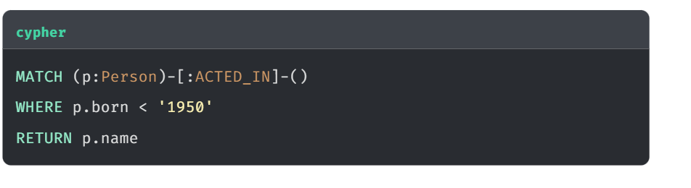

Here is what this Cypher statement does:

1. A node by label scan to retrieve all Person nodes.
2. Tests the born property for the nodes retrieved to filter them.
3. Determines which of these filtered nodes have the outgoing ACTED_IN relationship.
4. Returns the name property values.

### **Profiling a query**

You can use the PROFILE keyword to see the performance for a query.

**cypher**

PROFILE MATCH (p:Person)-[:ACTED_IN]-()

WHERE p.born < '1950'

RETURN p.name

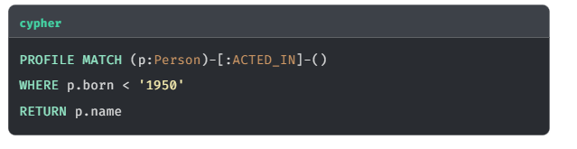

This is the result of the profile:

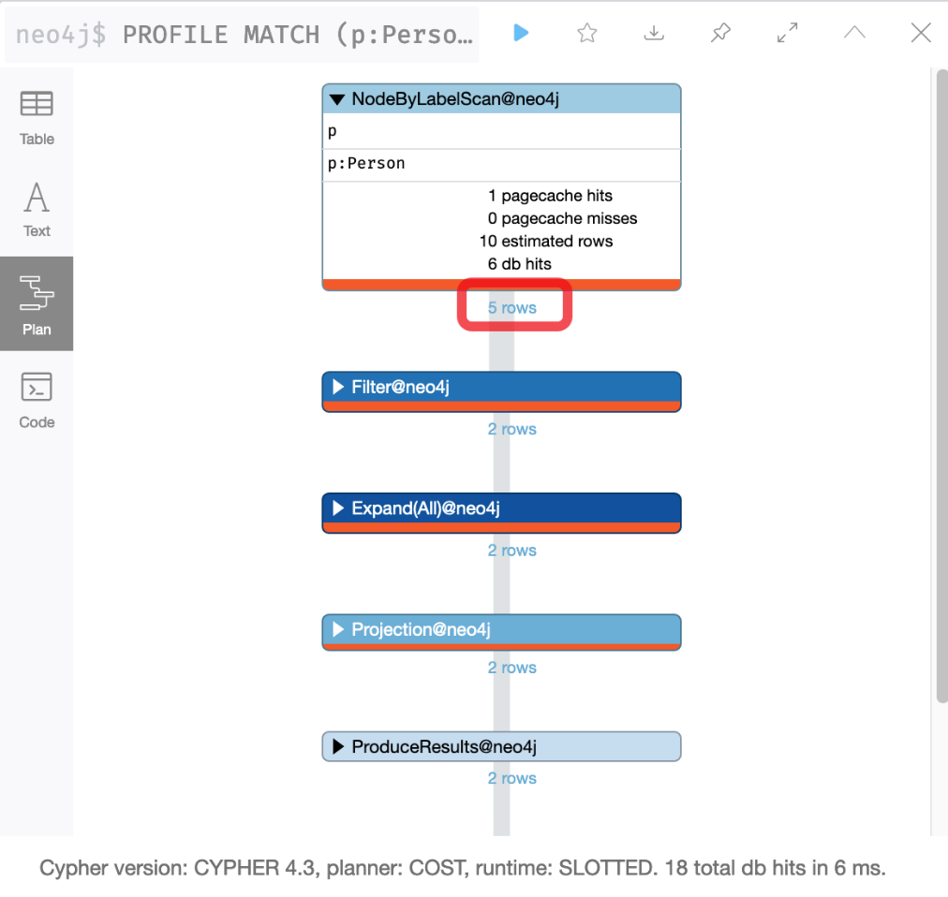

Because the cache is automatically populated, it is sometimes hard to measure performance with a small dataset. That is, db hits and elapsed time may not be comparable. What you can see, however, is the number of rows that are retrieved in the query and this number can be compared.

In the first step of this query, we see that 5 rows are returned. You can imagine that if this were a fully-loaded graph with millions of nodes, in step 1, it would need to retrieve a lot of Person nodes, some of which are not actors. One way that you can optimize this retrieval is to change the data model to include an Actor label for a Person node.

### **Refactoring the model**

If we refactor, the initial node by label scan would only retrieve the Actor nodes.

Here is the refactored instance model we will create in the graph:

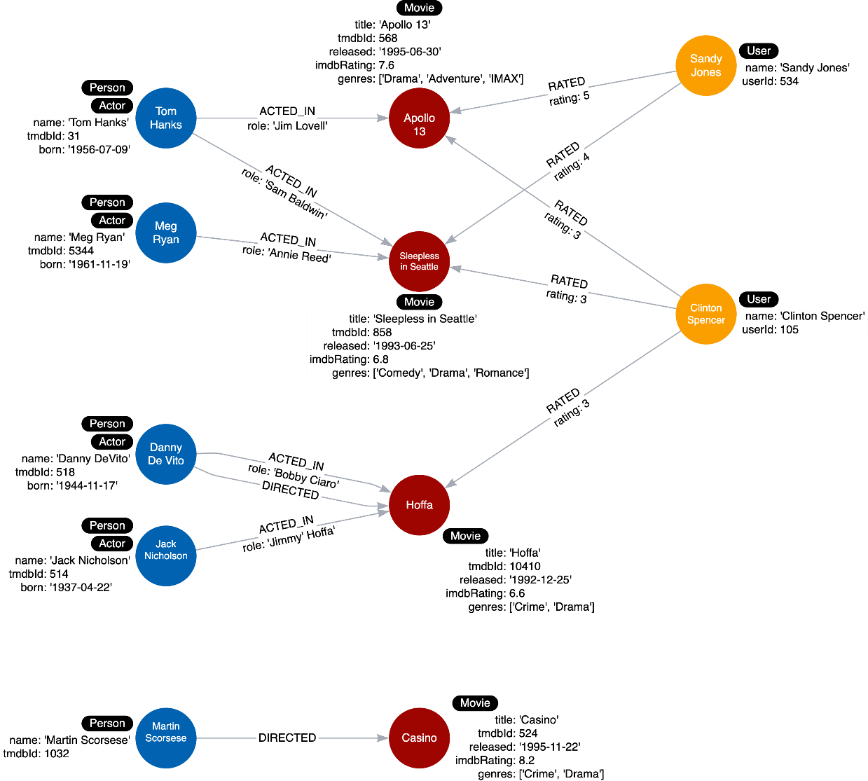

### **Refactor the graph**

With Cypher, you can easily transform the graph. With this code, that you will execute in the next Challenge, we find all Person nodes that have an ACTED_IN relationship. We then set a label for the node.

**cypher**

MATCH (p:Person)

WHERE exists ((p)-[:ACTED_IN]-())

SET p:Actor

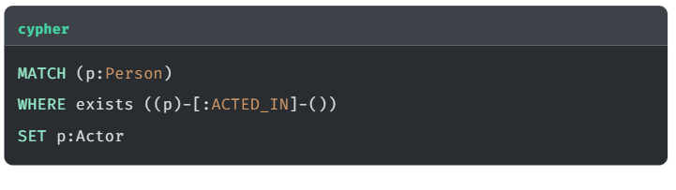

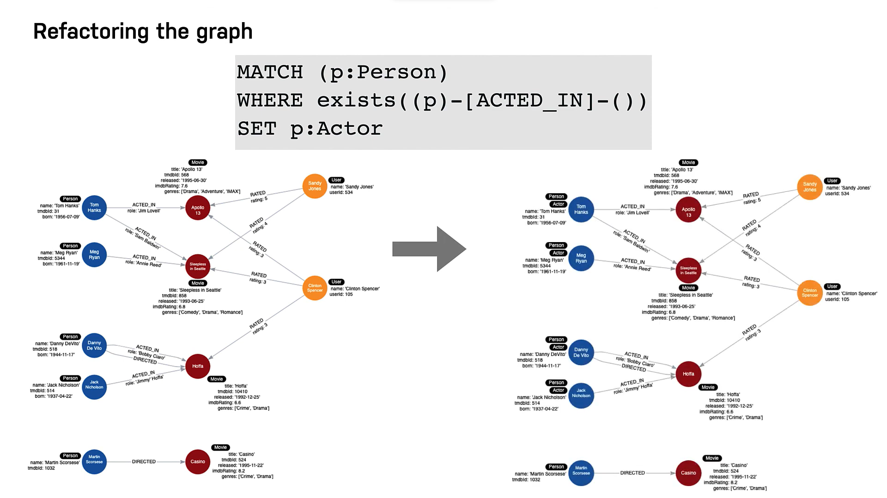

In the next Challenge, you will refactor the graph to add the Actor label.

### **Main Points-**

* 1. You add labels to nodes to reduce the number of data accessed at runtime
  2. A node should have a maximum of 4 labels

# Adding the Actor Label

Here is the refactored instance model we will create in the graph where we add an Actor label to some of the Person nodes:

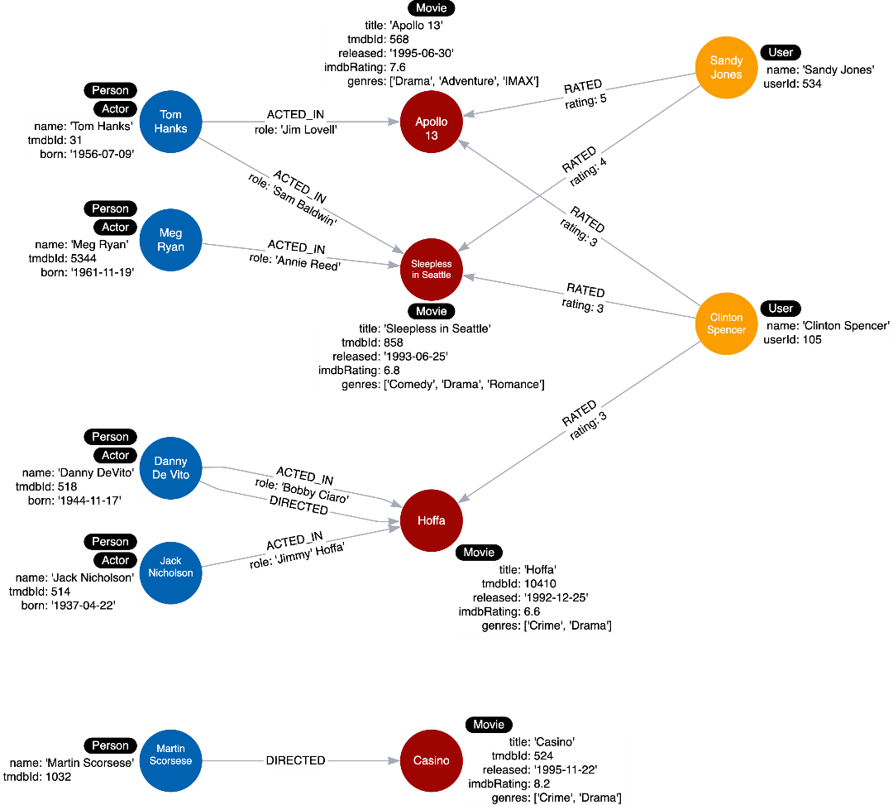

## **Profile the query**

Execute this query:

**cypher**

Copy to ClipboardRun in Sandbox

PROFILE MATCH (p:Person)-[:ACTED_IN]-()

WHERE p.born < '1950'

RETURN p.name

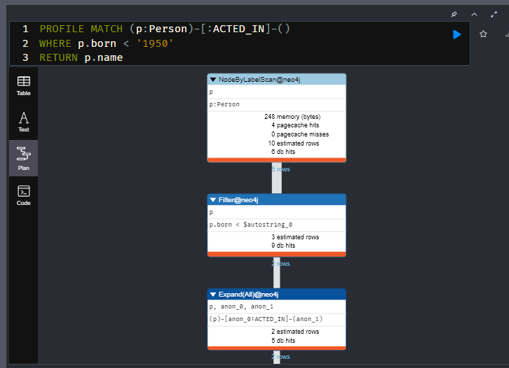

In the first step of this query, we see that 5 Person rows are returned.

## **Refactor the graph**

With Cypher, you can easily transform the graph to add Actor labels.

Execute this Cypher code to add the Actor label to the appropriate nodes:

**cypher**

**Add Actor Labels**

Copy to ClipboardRun in Sandbox

MATCH (p:Person)

WHERE exists ((p)-[:ACTED_IN]-())

SET p:Actor

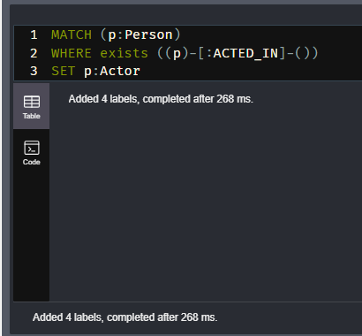

There are 5 Person nodes in the graph, but only 4 have an :ACTED_IN relationship. Therefore, the query above should apply the Actor label to four of the five Person nodes.

## Profile the query

Now that we have refactored the graph, we must change our query and profile again.

Execute this query:

**cypher**

Copy to ClipboardRun in Sandbox

PROFILE MATCH (p:Actor)-[:ACTED_IN]-()

WHERE p.born < '1950'

RETURN p.name

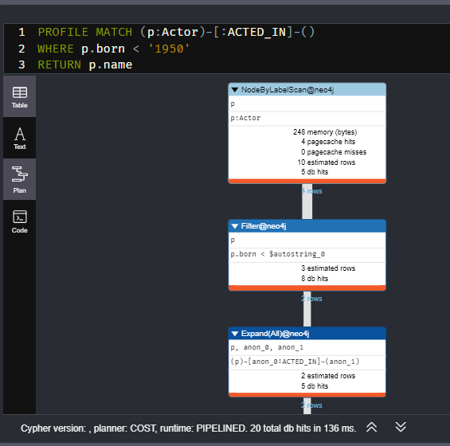

In the first step of this query, we see that 4 Actor rows are returned.

# Retesting After Refactoring

Youtube video: <https://youtu.be/QisAdQ68aDs>

Transcript-

**Retesting after refactoring**

After you have refactored the graph, you should revisit all queries for your use cases.

You should first determine if any of the queries need to be rewritten to take advantage of the refactoring.

Next, we rewrite some of our queries to take advantage of the refactoring.

During your testing on your real application and especially with a fully-scaled graph, you can also profile the new queries to see if it improves performance. On the small instance model we are using, you will not see significant improvements, but you may see differences in the number of rows retrieved.

Basically after refactoring the graph, you must **rewrite any Cypher queries** and **retest all use cases** that have been affected as an outcome of the refactoring.

**Use case #1: What people acted in a movie?**

We rewrite this query to use the *Actor* label.

Original code:

**cypher**

MATCH (p:Person)-[:ACTED_IN]-(m:Movie)

WHERE m.title = 'Sleepless in Seattle'

RETURN p.name AS Actor

New code:

**cypher**

MATCH (p:Actor)-[:ACTED_IN]-(m:Movie)

WHERE m.title = 'Sleepless in Seattle'

RETURN p.name AS Actor

**Profiling Queries**

For the query that uses the *Person* label we see this result that first retrieves the 5 *Person* nodes:

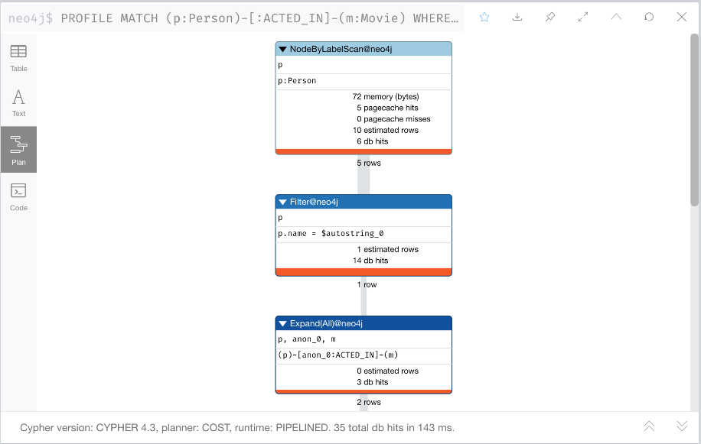

For the query that uses the *Actor* label we see this result that first retrieves the 4 *Actor* nodes, a slight improvement for this small graph:

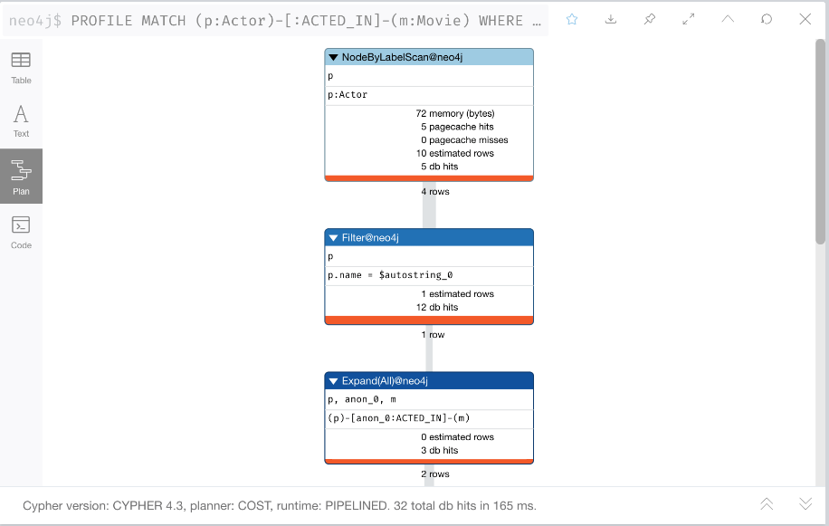

**Use case #3: What movies did a person act in?**

We rewrite this query to use the *Actor* label.

Original code:

**cypher**

MATCH (p:Person)-[:ACTED_IN]-(m:Movie)

WHERE p.name = 'Tom Hanks'

RETURN m.title AS Movie

New code:

**cypher**

MATCH (p:Actor)-[:ACTED_IN]-(m:Movie)

WHERE p.name = 'Tom Hanks'

RETURN m.title AS Movie

**Use case #5: Who was the youngest person to act in a movie?**

We rewrite this query to use the *Actor* label.

Original code:

**cypher**

MATCH (p:Person)-[:ACTED_IN]-(m:Movie)

WHERE m.title = 'Hoffa'

RETURN p.name AS Actor, p.born as `Year Born` ORDER BY p.born DESC LIMIT 1

New code:

**cypher**

MATCH (p:Actor)-[:ACTED_IN]-(m:Movie)

WHERE m.title = 'Hoffa'

RETURN p.name AS Actor, p.born as `Year Born` ORDER BY p.born DESC LIMIT 1

**Use case #6: What role did a person play in a movie?**

We rewrite this query to use the *Actor* label.

Original code:

**cypher**

MATCH (p:Person)-[r:ACTED_IN]-(m:Movie)

WHERE m.title = 'Sleepless in Seattle' AND

p.name = 'Meg Ryan'

RETURN r.role AS Role

New code:

**cypher**

MATCH (p:Actor)-[r:ACTED_IN]-(m:Movie)

WHERE m.title = 'Sleepless in Seattle' AND

p.name = 'Meg Ryan'

RETURN r.role AS Role

**Use case #8: What drama movies did an actor act in?**

We rewrite this query to use the *Actor* label.

Original code:

**cypher**

MATCH (p:Person)-[:ACTED_IN]-(m:Movie)

WHERE p.name = 'Tom Hanks' AND

'Drama' IN m.genres

RETURN m.title AS Movie

New code:

**cypher**

MATCH (p:Actor)-[:ACTED_IN]-(m:Movie)

WHERE p.name = 'Tom Hanks' AND

'Drama' IN m.genres

RETURN m.title AS Movie

**Use case #10: What actors were born before 1950?**

For completeness of our testing, we add this new use case.

We rewrite this query to use the *Actor* label.

Original code:

**cypher**

MATCH (p:Person)

WHERE p.born < '1950'

RETURN p.name

New code:

**cypher**

MATCH (p:Actor)

WHERE p.born < '1950'

RETURN p.name

**Profile queries**

If you have a scaled graph (with more nodes/relationships than what we have been using in this course), you should also use the PROFILE keyword to compare the performance of the queries after the refactoring.

* 1. **Retesting with Actor Label**

You have refactored the graph to add the *Actor* label to the appropriate nodes. You must now retest your use cases against the refactored graph.

Note that if you had a fully-scaled graph, you would see differences in the queries that use the *Person* label vs. the *Actor* label. You can profile the queries to compare the rows retrieved before an after.

**Use case #1: What people acted in a movie?**

Run this Cypher code to test this use case using the movie, Sleepless in Seattle.

**cypher**

Copy to ClipboardRun in Sandbox

MATCH (p:Actor)-[:ACTED_IN]-(m:Movie)

WHERE m.title = 'Sleepless in Seattle'

RETURN p.name AS Actor

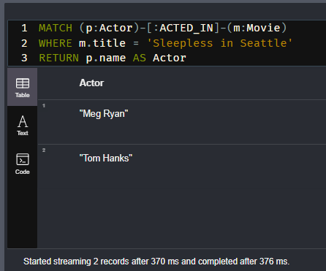

It should return two names of actors, Tom Hanks, and Meg Ryan.

**Use case #3: What movies did a person act in?**

Run this Cypher code to test this use case using the person, Tom Hanks.

**cypher**

Copy to ClipboardRun in Sandbox

MATCH (p:Actor)-[:ACTED_IN]-(m:Movie)

WHERE p.name = 'Tom Hanks'

RETURN m.title AS Movie

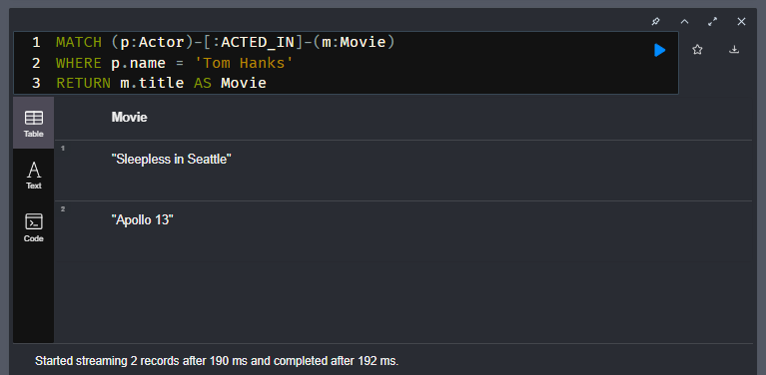

It should return the movies Apollo 13 and Sleepless in Seattle.

**Use case #5: Who was the youngest person to act in a movie?**

Run this Cypher code to test this use case with the movie, Hoffa.

**cypher**

Copy to ClipboardRun in Sandbox

MATCH (p:Actor)-[:ACTED_IN]-(m:Movie)

WHERE m.title = 'Hoffa'

RETURN p.name AS Actor, p.born as `Year Born` ORDER BY p.born DESC LIMIT 1

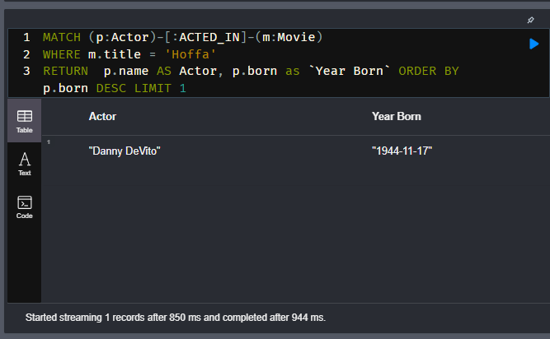

It should return Danny DeVito with his birth year.

**Use case #6: What role did a person play in a movie?**

Run this Cypher code to test this use case with the movie, Sleepless in Seattle and the person, Meg Ryan.

**cypher**

Copy to ClipboardRun in Sandbox

MATCH (p:Actor)-[r:ACTED_IN]-(m:Movie)

WHERE m.title = 'Sleepless in Seattle' AND

p.name = 'Meg Ryan'

RETURN r.role AS Role

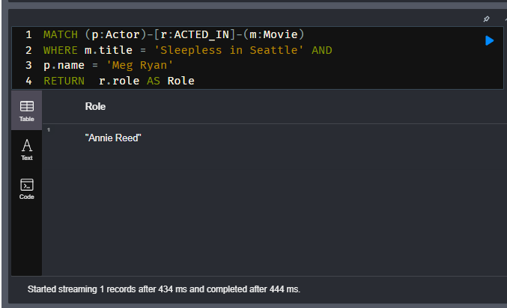

It should return Annie Reed.

**Use case #8: What drama movies did an actor act in?**

Run this Cypher code to test this use case with the person, Tom Hanks.

**cypher**

Copy to ClipboardRun in Sandbox

MATCH (p:Actor)-[:ACTED_IN]-(m:Movie)

WHERE p.name = 'Tom Hanks' AND

'Drama' IN m.genres

RETURN m.title AS Movie

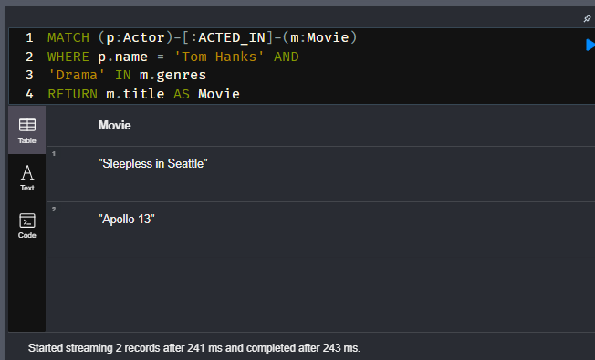

If you were to change 'Drama' to 'Comedy' in this query, it would return a different result.

**Use case #10: What actors were born before 1950?**

Run this Cypher code to test this use case with the year 1950.

**cypher**

Copy to ClipboardRun in Sandbox

MATCH (p:Actor)

WHERE p.born < '1950'

RETURN p.name

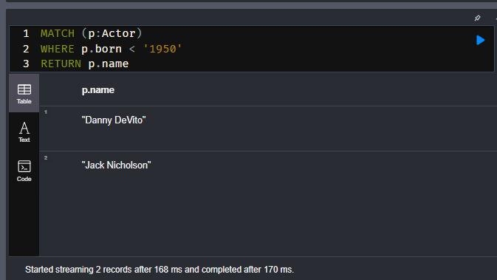

It should return the actors, Danny DeVito and Jack Nicholson

Run this Cypher code to return everything in the graph and answer the next question.

**cypher**

Copy to ClipboardRun in Sandbox

MATCH (n)

RETURN n

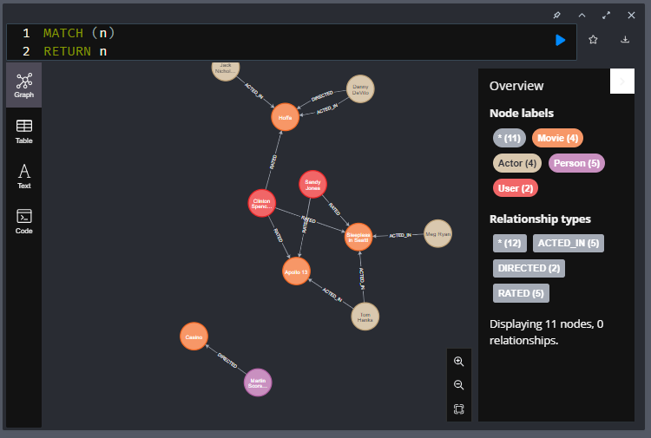

* 1. **Adding the Director Label**

In a previous Challenge, you added the *Actor* label to the nodes in the graph.

Modify the query in the sandbox query pane to label the *Person* nodes that have the outgoing relationship of *DIRECTED* to be labeled *Director*.

The new label will be *Director*. Your code should add 2 labels to the graph.

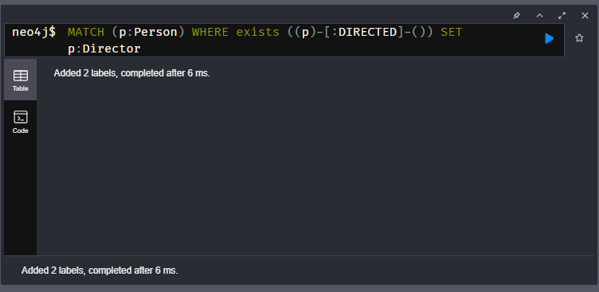

After refactoring the graph, you must test any use cases that are affected.

**Use case #2: What person directed a movie?**

Copy this query into the query pane, and modify it to use the *Director* label, then test this use case using the movie, Hoffa.

**cypher**

Copy to Clipboard

MATCH (p:Person)-[:DIRECTED]-(m:Movie)

WHERE m.title = 'Hoffa'

RETURN p.name AS Director

It should return Danny DeVito.

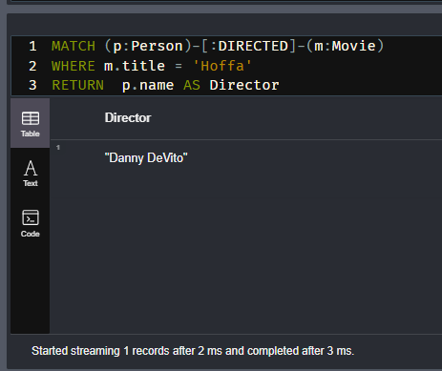

## Summary

In this challenge, you demonstrated that you can refactor the graph to add a DIRECTOR label to some of its nodes and retest relevant use cases.

Your instance model should now look like this:

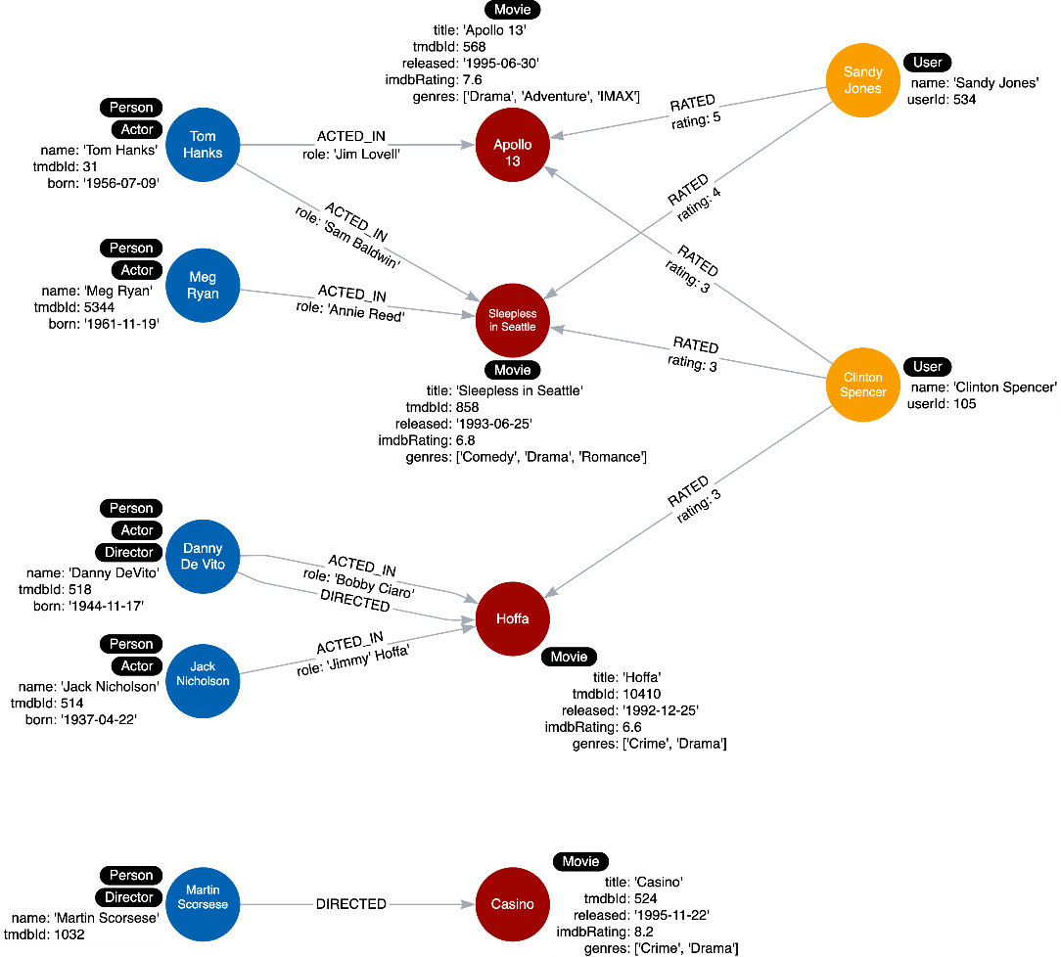

In the next lesson, you will learn some tips about what not to do with labels in your graph data model.

# Avoid These Labels

Youtube video: <https://youtu.be/b5hJ6L60yTM>

Transcript-

## **Semantically orthogonal labels**

“Semantically orthogonal” is a fancy term that means that labels should have nothing to do with one another. You should be careful not to use the same type of label in different contexts. For example, using the region for all types of nodes is not useful for most queries.

Here is an example where both Person nodes and User nodes are labeled with regions. If there are no use cases where the region is significant for both types of nodes, it is not helpful to use these same labels for Person nodes and User nodes.

Don’t do this:

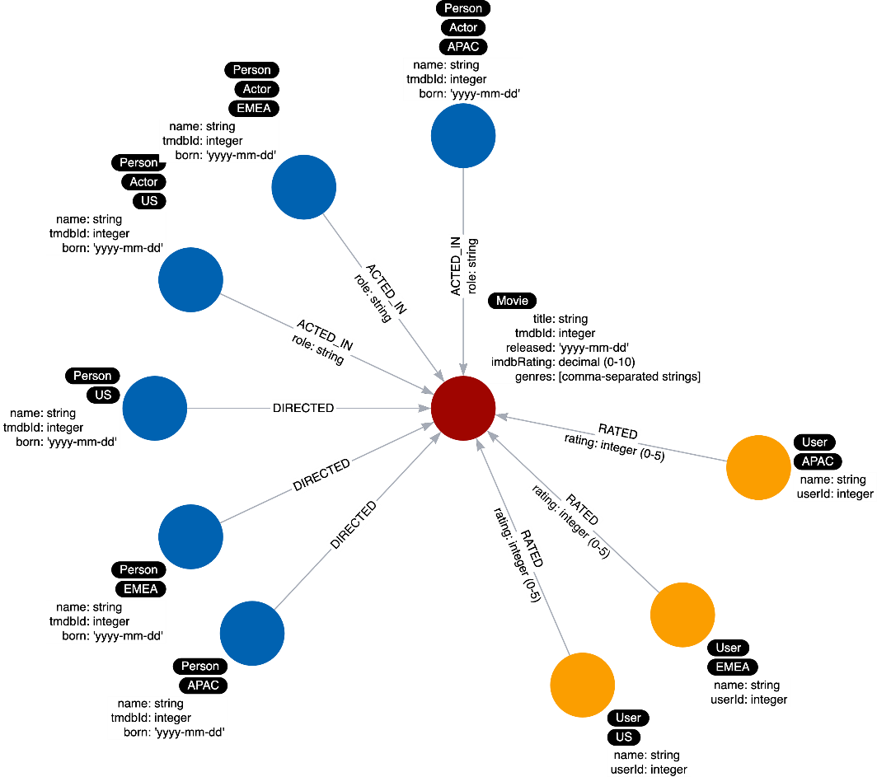

### **Representing class hierarchies**

You also want to avoid labeling your nodes to represent hierarchies.

Suppose we have this hierarchy of Screen Actors Guild memberships:

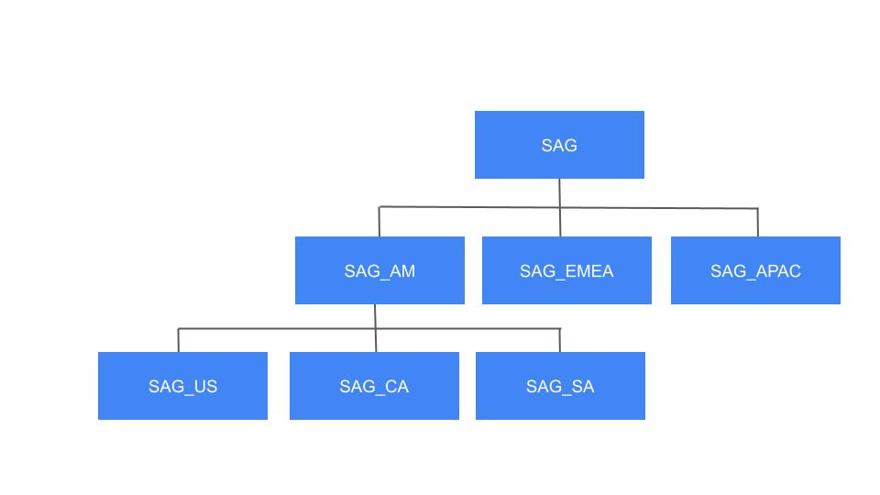

This is often called “inheritance” or “IS-A” relationships. You should not do this where nodes have multiple labels that represent a hierarchy such as this:

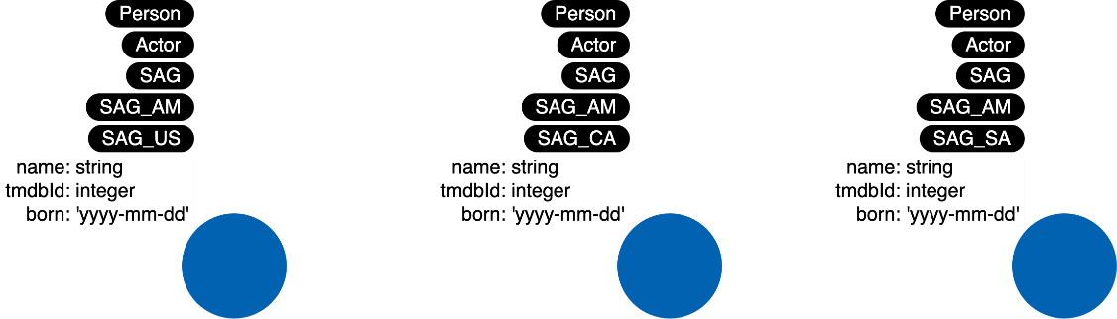

Instead, you should do this:

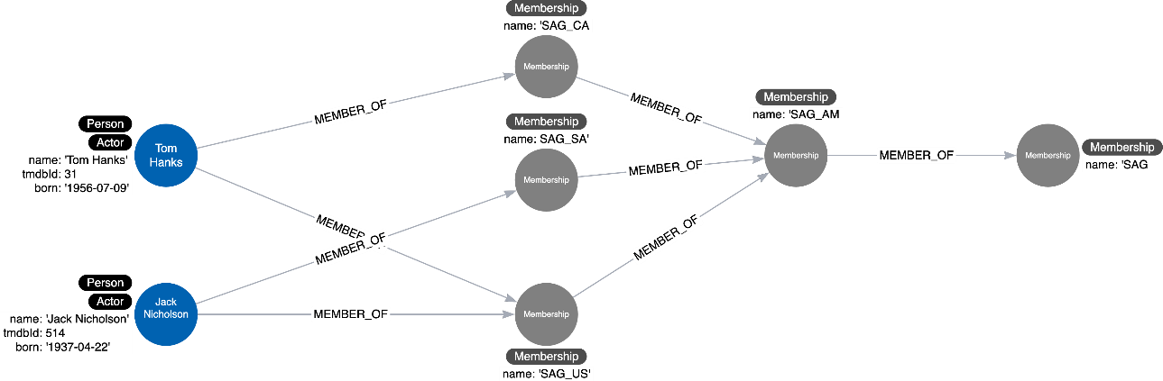

In Summary

The two practices that you should avoid are **Semantically orthogonal labels** and **labels that represent hierarchies**.

# Module 6: Eliminating Duplicate Data

**Module Overview**

In this module, you will learn about:

* Creating nodes from properties where property values are duplicated in the graph.
* Eliminating complex data in nodes that is expensive to query.

# Eliminating Duplicate Data

Youtube video: <https://youtu.be/2JiFIfre2wM>

Transcript-

## **Duplicate data**

You should take care to avoid duplicating data in your graph. Where some databases require a form of denormalization to improve the speed of a set of queries, this is not always the case with a graph database. De-duplicating data gives you the added benefit of allowing you to query through a node - for example, finding other customers who have purchased a particular product, or finding similar movies based on the rating of other users.

In addition, duplicating data in the graph increases the size of the graph and the amount of data that may need to be retrieved for a query.

### **New use case**

We have a new use case that we must account for.

**Use case #11: What movies are available in a particular language?**

Our current instance model looks like this:

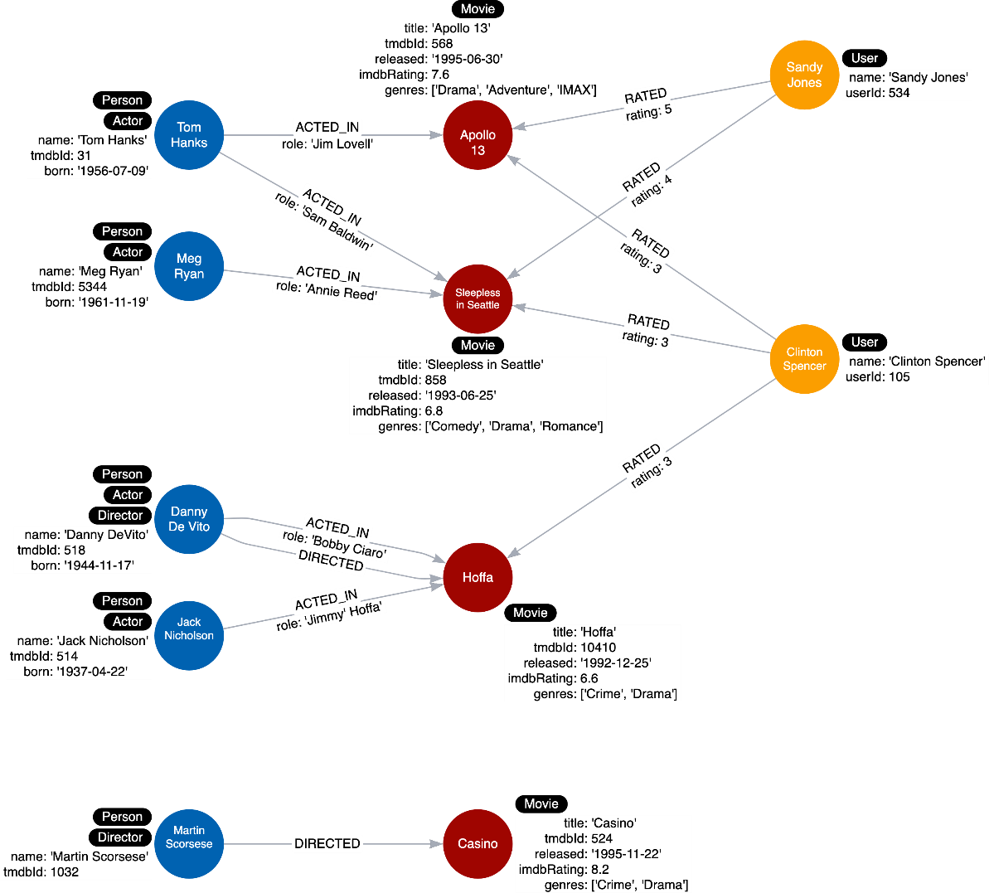

As you can see we do not account for languages in the data model so we will have to add this data.

### **Duplicate data example**

Suppose we add a property to each Movie node in the graph named languages that represents the languages in which a movie is available.

Here is what the instance model would look like:

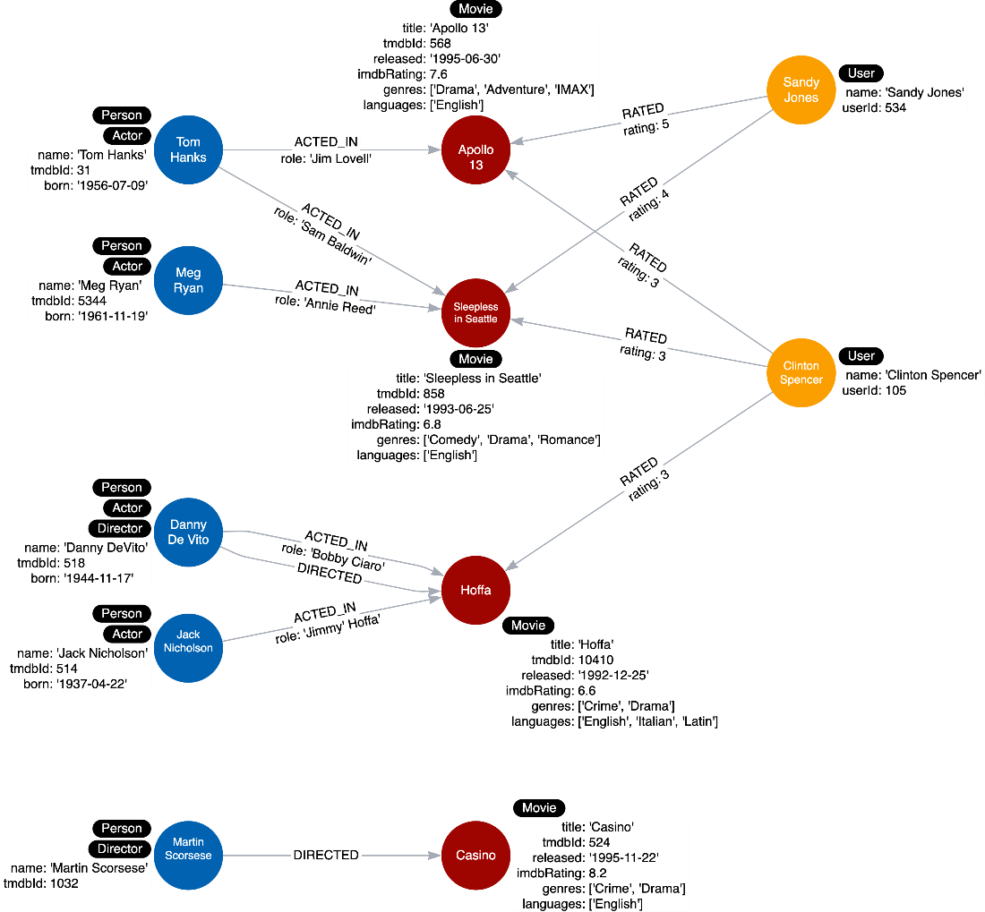

Here we see that all Movie nodes have English in the list of languages. This is duplicate data and for a scaled database, would represent a lot of duplication.

# Adding Language Data

In the previous lesson, you learned that duplicating data in the graph can be expensive. To illustrate duplication of data, you will add a languages property to each Movie node in the instance model.

Execute this Cypher code to add a languages property to the Movie nodes of the graph:

**cypher**

**Adding a Language Property**

Copy to ClipboardRun in Sandbox

MATCH (apollo:Movie {title: 'Apollo 13', tmdbId: 568, released: '1995-06-30', imdbRating: 7.6, genres: ['Drama', 'Adventure', 'IMAX']})

MATCH (sleep:Movie {title: 'Sleepless in Seattle', tmdbId: 858, released: '1993-06-25', imdbRating: 6.8, genres: ['Comedy', 'Drama', 'Romance']})

MATCH (hoffa:Movie {title: 'Hoffa', tmdbId: 10410, released: '1992-12-25', imdbRating: 6.6, genres: ['Crime', 'Drama']})

MATCH (casino:Movie {title: 'Casino', tmdbId: 524, released: '1995-11-22', imdbRating: 8.2, genres: ['Drama','Crime']})

SET apollo.languages = ['English']

SET sleep.languages = ['English']

SET hoffa.languages = ['English', 'Italian', 'Latin']

SET casino.languages = ['English']

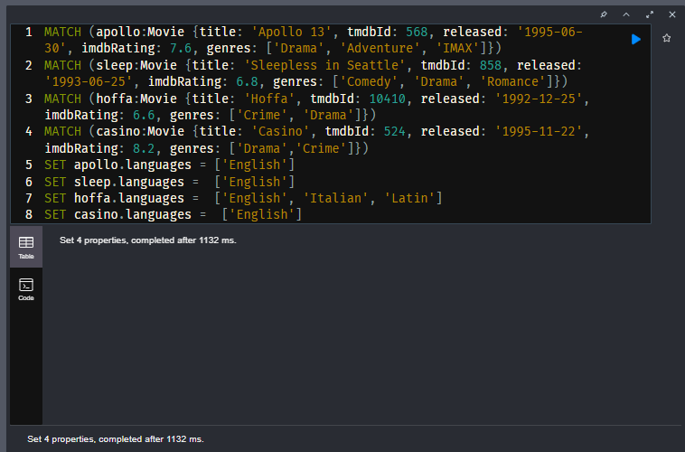

And here is the associated instance model:

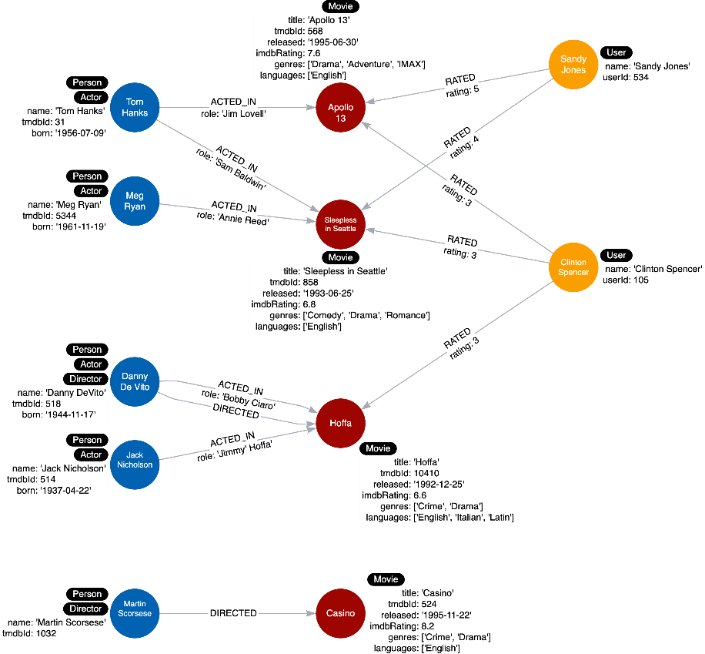

## Querying languages

Here is a query to support our new use case:

**Use case #11: What movies are available in a particular language?**

With this query, we find all movies in Italian.

Execute this query and answer the next question.

**cypher**

**Movies in Italian**

Copy to ClipboardRun in Sandbox

MATCH (m:Movie)

WHERE 'Italian' IN m.languages

RETURN m.title

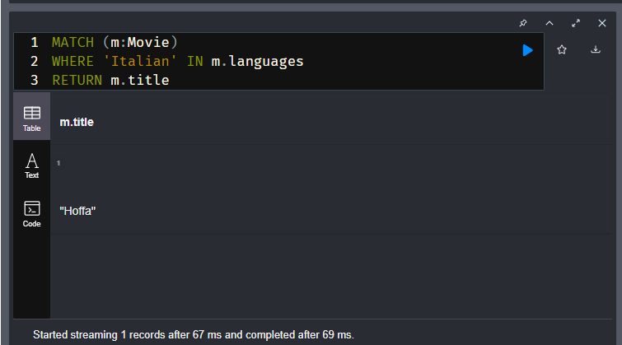

# Refactoring Duplicate Data

Youtube video: <https://youtu.be/031EBK550eE>

Transcript-

## **Querying duplicate data**

Here is our current instance model where each Movie node has a languages property:

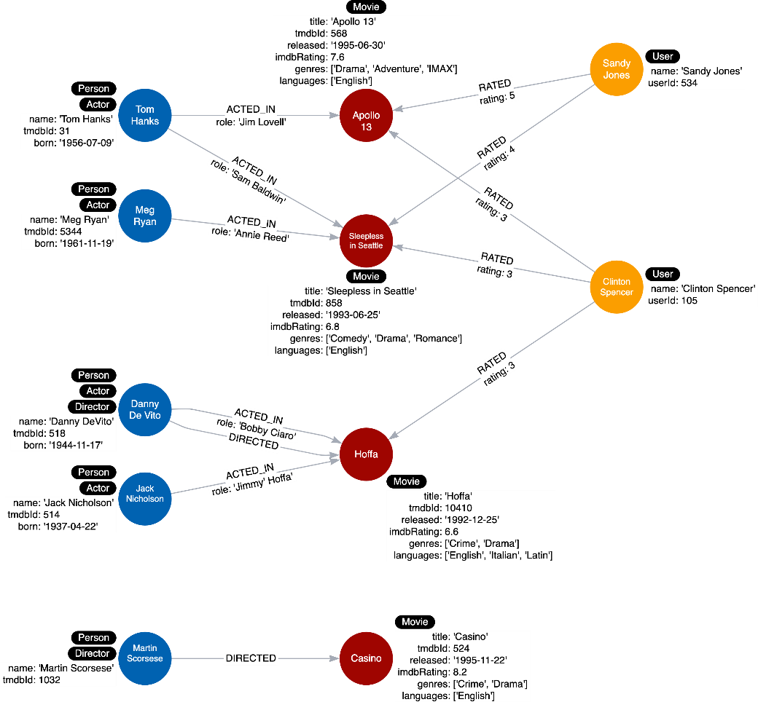

For our latest use case:

**Use case #11: What movies are available in a particular language?**

This query finds all movies in Italian:

**cypher**

MATCH (m:Movie)

WHERE 'Italian' IN m.languages

RETURN m.title

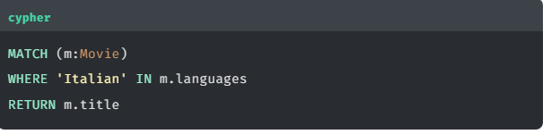

What this query does is retrieve all Movie nodes and then test whether the languages property contains Italian. There are two issues with the data model, especially if the graph scales:

* The name of the language is duplicated in many Movie nodes.
* In order to perform the query, all Movie nodes must be retrieved.

A solution here is to model properties as nodes.

### **Refactor properties as nodes**

Here are the steps we use to refactor:

1. We take the property values for each Movie node and create a Language node.
2. Then we create the IN_LANGUAGE relationship between that Movie node and the Language node.
3. Finally, we remove the languages property from the Movie node.

This is the code to refactor the graph to turn the property values into nodes:

**cypher**

MATCH (m:Movie)

UNWIND m.languages AS language

WITH language, collect(m) AS movies

MERGE (l:Language {name:language})

WITH l, movies

UNWIND movies AS m

WITH l,m

MERGE (m)-[:IN_LANGUAGE]->(l);

MATCH (m:Movie)

SET m.languages = null

This code iterates through all Movie nodes and creates a Language node for each language it finds and then creates the relationship between the Movie node and Language node using the IN_LANGUAGE relationship. It uses the Cypher UNWIND clause to separate each element of the languages property list into a separate row value that is processed later in the query.

The UNWIND clause is used to separate a list into individual elements.

This is what the instance model looks like after the refactoring:

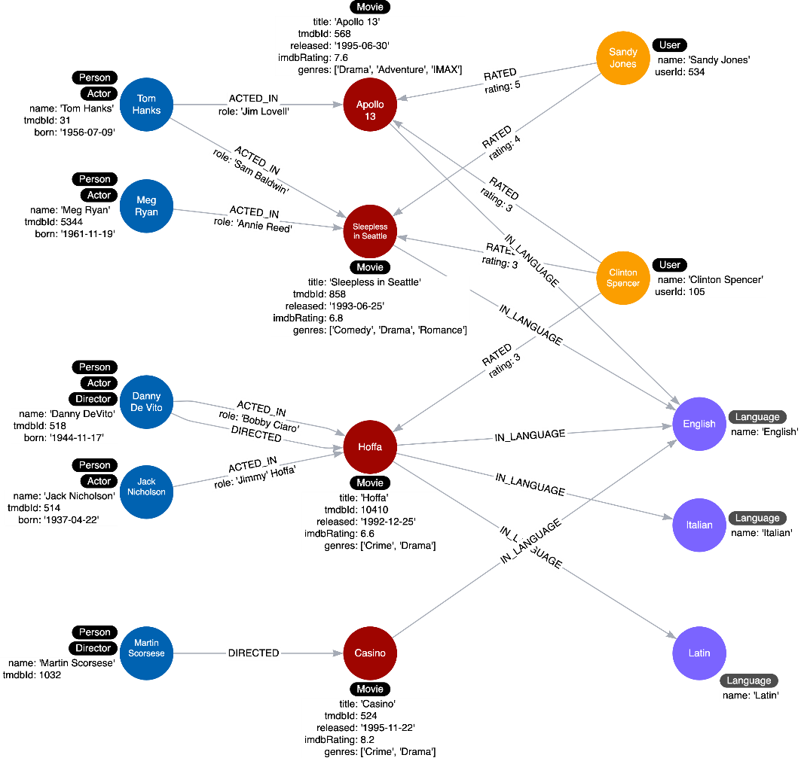

There will only be one node with the language value of English and we remove the languages property from all Movie nodes. This eliminates a lot of duplication in the graph.

# Adding Language nodes

* This is what the instance model will be refactored to:

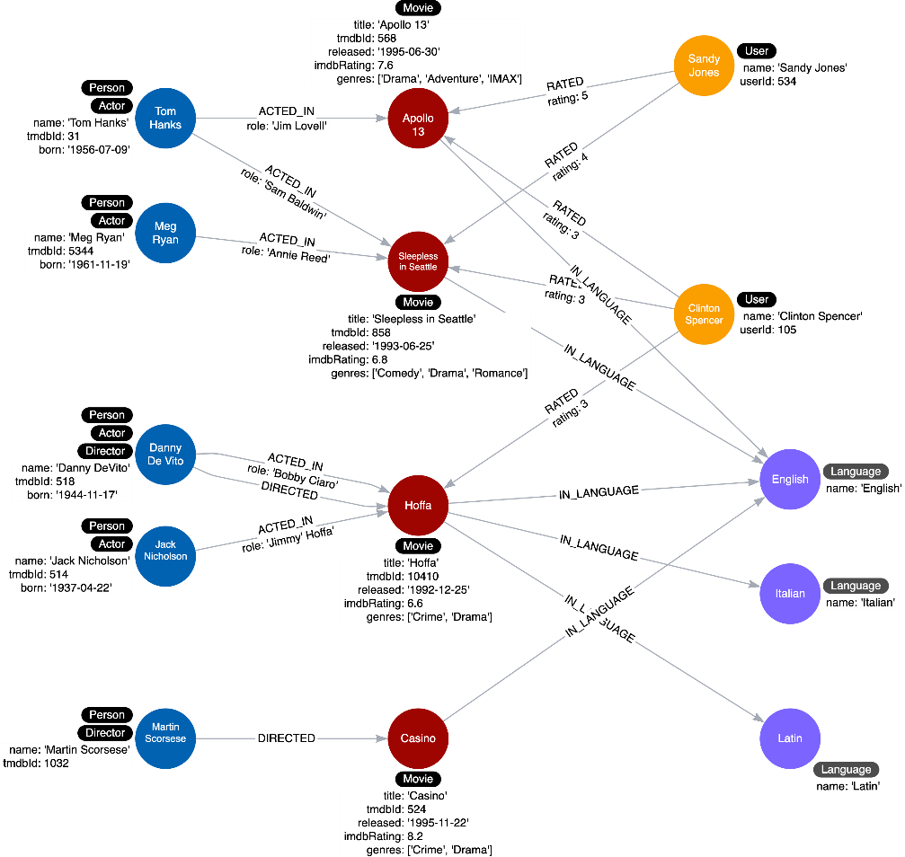

## **Creating Language Nodes**

* Execute this code to refactor the graph to turn the languages property values into Language nodes:
* **cypher**
* **Creating Language Nodes**
* Copy to ClipboardRun in Sandbox
* MATCH (m:Movie)
* UNWIND m.languages AS language
* WITH language, collect(m) AS movies
* MERGE (l:Language {name:language})
* WITH l, movies
* UNWIND movies AS m
* WITH l,m
* MERGE (m)-[:IN_LANGUAGE]->(l);
* MATCH (m:Movie)
* SET m.languages = null

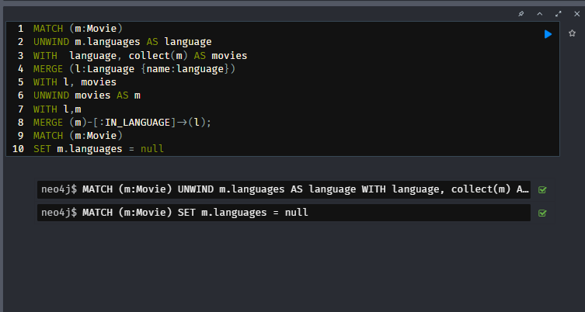

## **Modifying the Cypher statement**

* This is the Cypher code for what our use case used to be before the refactoring.
* **cypher**
* **Previous Query**
* Copy to Clipboard
* MATCH (m:Movie)
* WHERE 'Italian' IN m.languages
* RETURN m.title

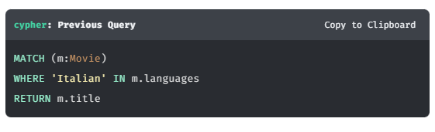

* This query can now be modified to instead use the newly-created Language node.
* **cypher**
* **Using the Language Node**
* Copy to ClipboardRun in Sandbox
* MATCH (m:Movie)-[:IN_LANGUAGE]-(l:Language)
* WHERE l.name = 'Italian'
* RETURN m.title

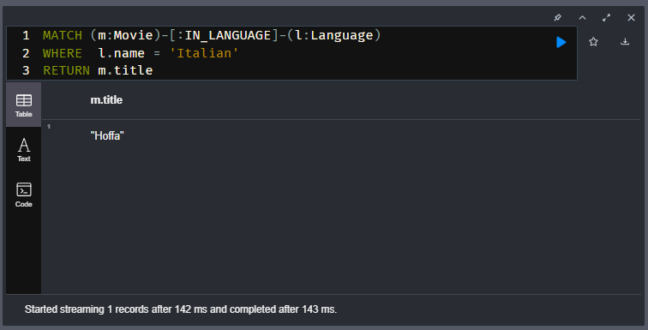

* This is the only use case that deals with languages so we need not retest all of our queries after the refactor.

# Adding Genre nodes

In the previous Challenge, you eliminated duplication by taking the data in the *languages* property and creating *Language* nodes that are related to movies.

This challenge has three steps:

1. Modify and run the query in the sandbox query pane to use the data in the *genres* property for the *Movie* nodes and create *Genre* nodes using the *IN_GENRE* relationship to connect *Movie* nodes to *Genre* nodes.
2. Delete the *genres* property from the *Movie* nodes.
3. Rewrite the query for the use case: **What drama movies did an actor act in?**

Copy this query to the sandbox query pane, rewrite it, and test this Cypher statement to test this use case with the person, Tom Hanks.

**cypher**

Copy to Clipboard

MATCH (p:Actor)-[:ACTED_IN]-(m:Movie)

WHERE p.name = 'Tom Hanks' AND

'Drama' IN m.genres

RETURN m.title AS Movie

It should return the movies Apollo 13 and Sleepless in Seattle.

### **Solution I tried and worked (maybe wrong)-**

MATCH (m:Movie)

UNWIND m.genres AS genre

WITH genre, collect(m) AS movies

MERGE (g:Genre {name:genre})

WITH g, movies

UNWIND movies AS m

WITH g,m

MERGE (m)-[:IN_GENRE]->(g)

SET m.genres = null

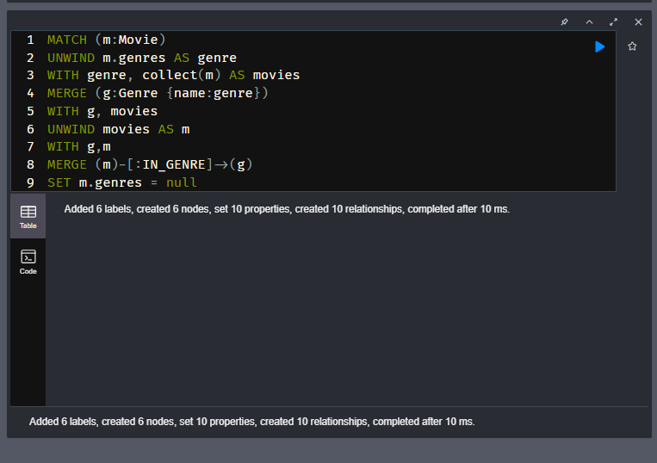

MATCH (p:Actor)-[:ACTED_IN]-(m:Movie)

MATCH (m:Movie)-[:IN_GENRE]-(g:Genre)

WHERE p.name = 'Tom Hanks' AND

g.name = 'Drama'

RETURN m.title AS Movie

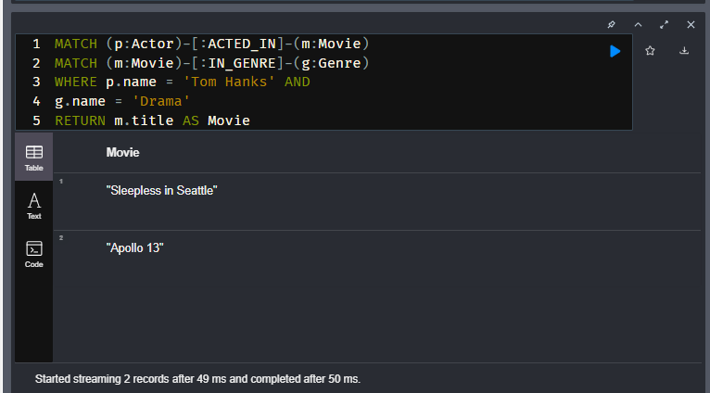

### **Given Solution-**

**cypher**

Copy to ClipboardRun in Sandbox

*//refactor code*

MATCH (m:Movie)

UNWIND m.genres AS genre

MERGE (g:Genre {name: genre})

MERGE (m)-[:IN_GENRE]->(g)

SET m.genres = null;

*//revised query*

MATCH (p:Actor)-[:ACTED_IN]-(m:Movie)--(g:Genre)

WHERE p.name = 'Tom Hanks' AND

g.name = 'Drama'

RETURN m.title AS Movie

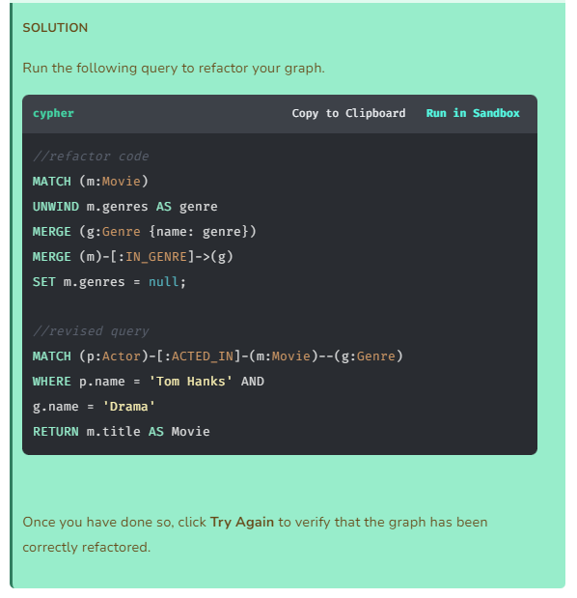

Instance model after the refactoring-

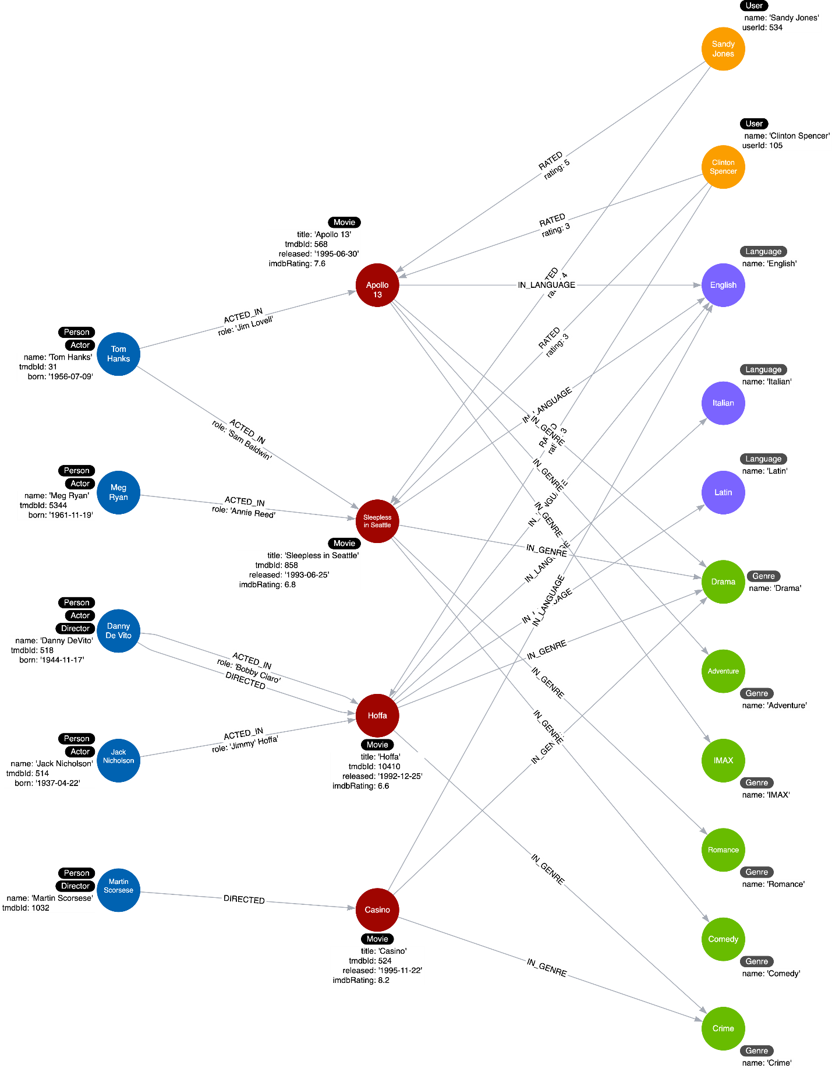

# Eliminating Complex Data in Nodes

Youtube video: <https://youtu.be/M-C36v-ayJg>

Transcript-

## Example: Complex data

Since nodes are used to store data about specific entities, you may have initially modeled, for example, a Production node to contain the details of the address for the production company.

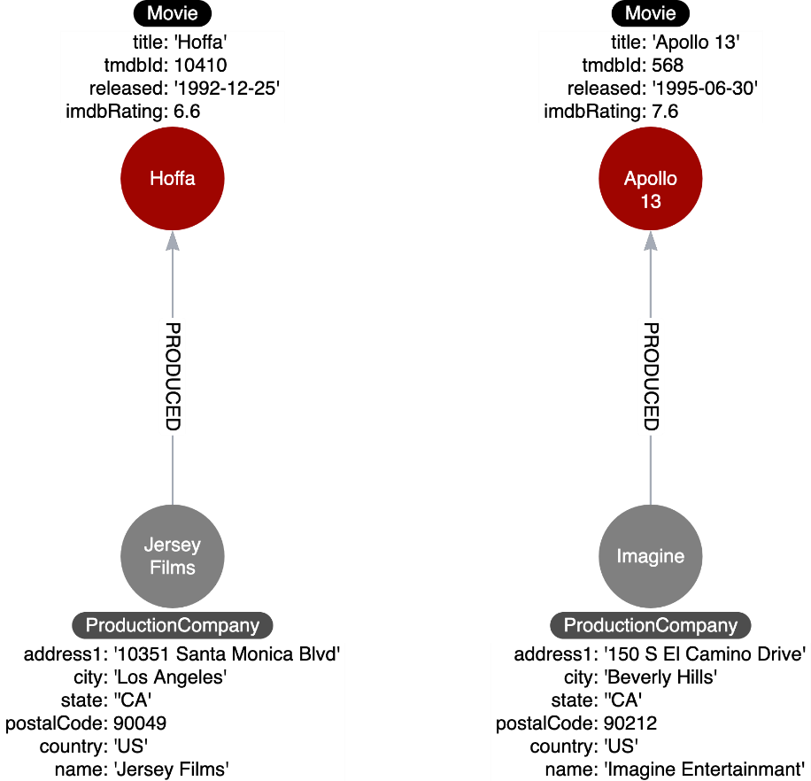

Storing complex data in the nodes like this may not be beneficial for a couple of reasons:

1. Duplicate data. Many nodes may have production companies in a particular location and the data is repeated in many nodes.
2. Queries related to the information in the nodes require that all nodes be retrieved.

### Refactoring complex data

If there is a high amount of duplicate data in the nodes or if key questions of your use cases would perform better if all nodes need not be retrieved to get at the complex data, then you might consider refactoring the graph as shown here.

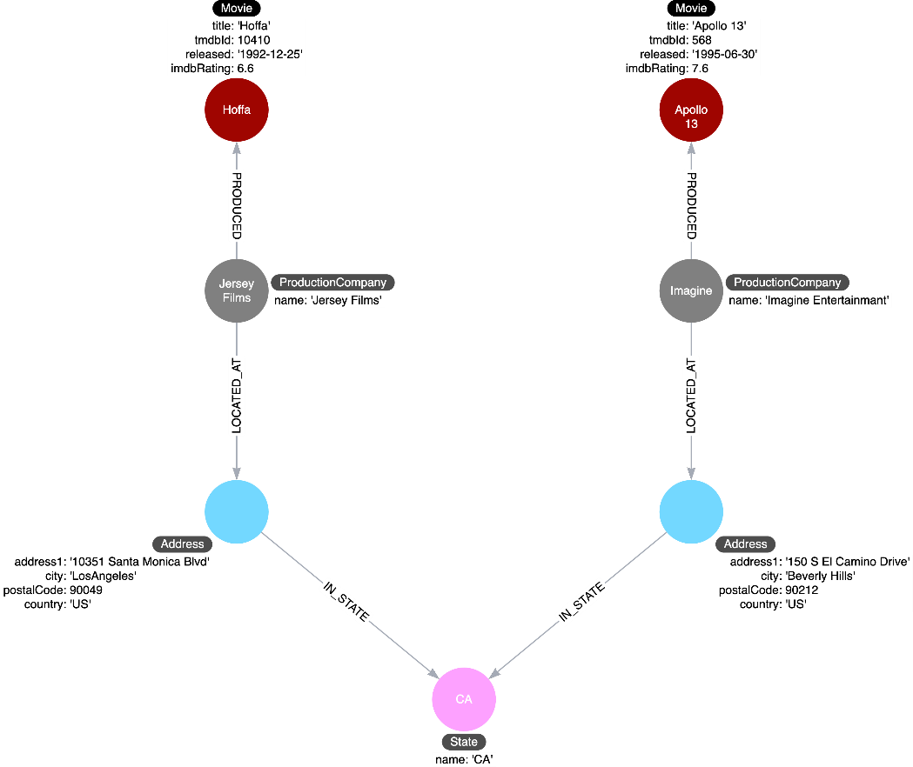

In this refactoring, if there are queries that need to filter production companies by their state, then it will be faster to query based upon the State.name value, rather than evaluating all of the state properties for the Production nodes.

How you refactor your graph to handle complex data will depend upon the performance of the queries when your graph scales.

# Module 7: Using Specific Relationships

## **Module Overview**

In this module, you will learn about:

* Why specialized relationships can be beneficial.
* Dynamically creating relationships to specialize relationships in the graph.

# Specific Relationships

Youtube video: <https://youtu.be/lv4W7030rkU>

Transcript-

## **Relationships in the graph**

Neo4j as a native graph database is implemented to traverse relationships quickly. In some cases, it is more performant to query the graph based upon relationship types, rather than properties in the nodes.

Let’s look at a new use case:

**Use case #12: What movies did an actor act in for a particular year?**

We can execute this query with the current graph:

**cypher**

MATCH (p:Actor)-[:ACTED_IN]-(m:Movie)

WHERE p.name = 'Tom Hanks' AND

m.released STARTS WITH '1995'

RETURN m.title AS Movie

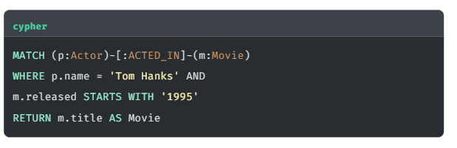

It returns the movie, Apollo 13:

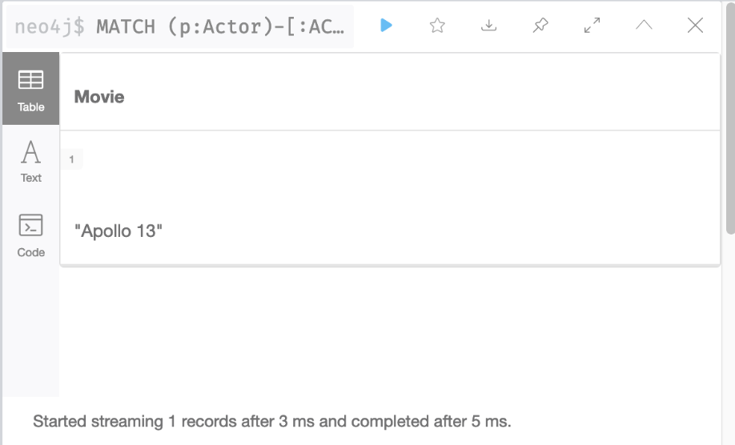

What if Tom Hanks acted in 50 movies in the year 1995? The query would need to retrieve all movies that Tom Hanks acted in and then check the value of the released property. What if Tom Hanks acted in a total of 1000 movies? All of these Movie nodes would need to be evaluated.

And here is another new use case:

**Use case #13: What actors or directors worked in a particular year?**

Again, we can execute this query with the current graph:

**cypher**

MATCH (p:Person)--(m:Movie)

WHERE m.released STARTS WITH '1995'

RETURN DISTINCT p.name as `Actor or Director`

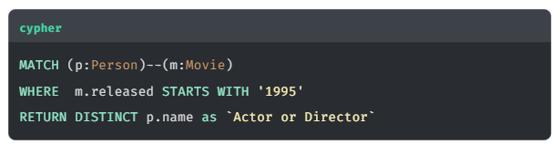

It returns Tom Hanks and Martin Scorsese:

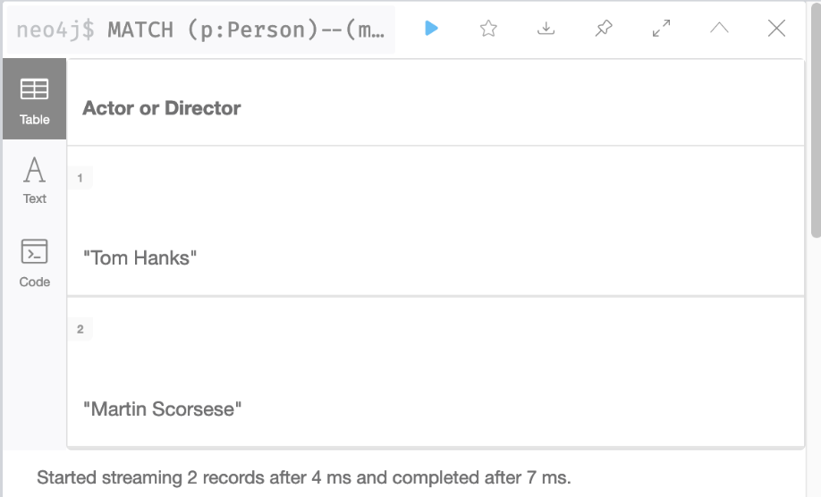

This query is even worse for performance because in order to return results, it must retrieve **all** Movie nodes. You can imagine, if the graph contained millions of movies, it would be a very expensive query.

### **Refactoring to specialize relationships**

Relationships are fast to traverse and they do not take up a lot of space in the graph. In the previous two queries, the data model would benefit from having specialized relationships between the nodes.

So, for example, in addition to the ACTED_IN and DIRECTED relationships, we add relationships that have year information.

* ACTED_IN_1992
* ACTED_IN_1993
* ACTED_IN_1995
* DIRECTED_1992
* DIRECTED_1995

At first, it seems like a lot of relationships for a large, scaled movie graph, but if the latest two new queries are important use cases, it is worth it.

This is what our instance model will now look like:

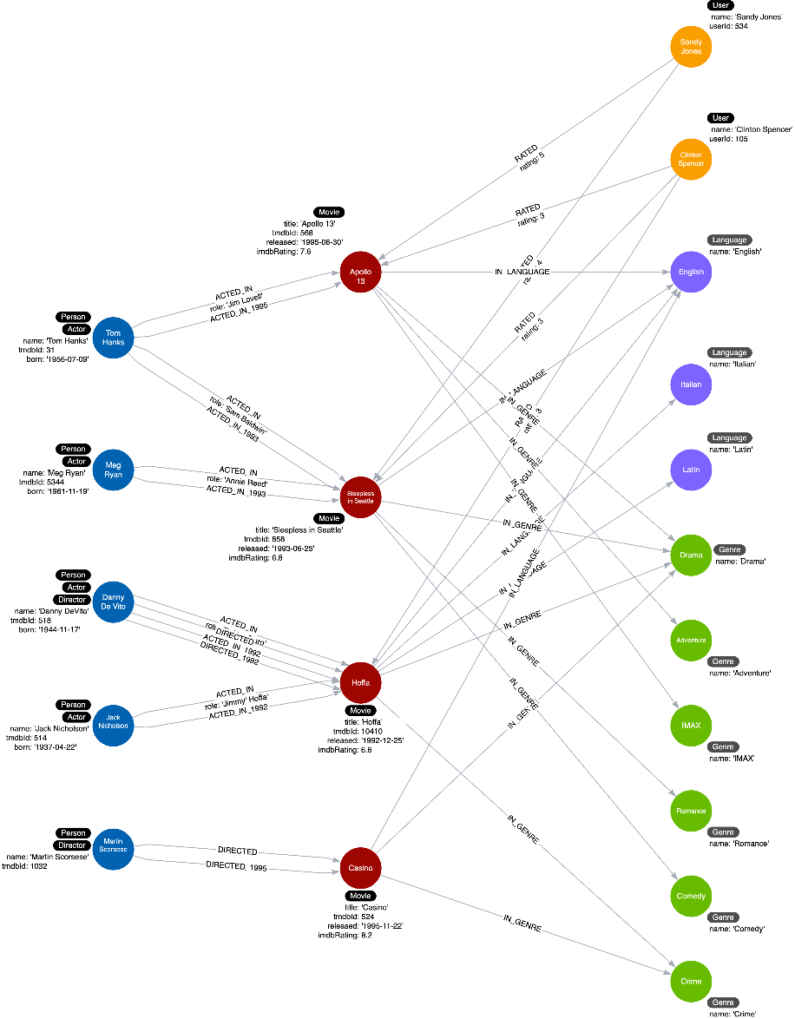

In most cases where we specialize relationships, we keep the original generic relationships as existing queries still need to use them.

The code to refactor the graph to add these specialized relationships uses the APOC library.

This is the code to refactor the ACTED_IN relationships in the graph that you will execute in the next Challenge:

**cypher**

MATCH (n:Actor)-[:ACTED_IN]->(m:Movie)

CALL apoc.merge.relationship(n,

'ACTED_IN_' + left(m.released,4),

{},

{},

m ,

{}

) YIELD rel

RETURN count(*) AS `Number of relationships merged`;

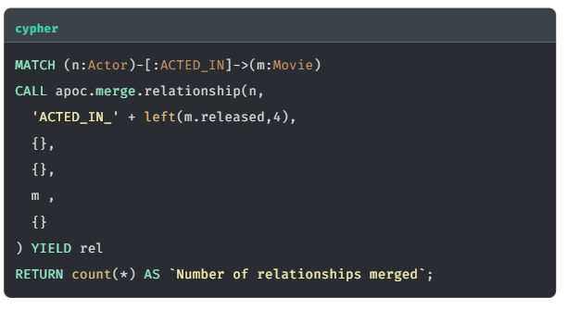

It has a apoc.merge.relationship procedure that allows you to dynamically create relationships in the graph. It uses the 4 leftmost characters of the released property for a Movie node to create the name of the relationship.

As a result of the refactoring, the previous two queries can be rewritten and will definitely perform better for a large graph:

Here is the rewrite of the first query:

**cypher**

MATCH (p:Actor)-[:ACTED_IN_1995]-(m:Movie)

WHERE p.name = 'Tom Hanks'

RETURN m.title AS Movie

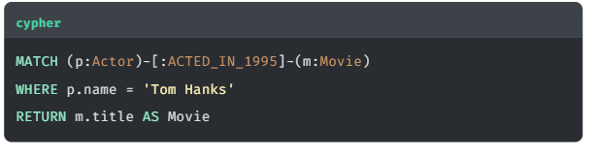

For this query the specific relationship is traversed, but fewer Movie nodes are retrieved.

And here is how we rewrite the second query:

**cypher**

MATCH (p:Person)-[:ACTED_IN_1995|DIRECTED_1995]-()

RETURN p.name as `Actor or Director`

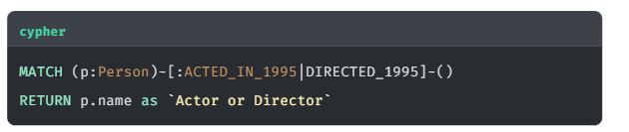

For this query, because the year is in the relationship type, we do not have to retrieve any Movie nodes.

### In Summary-

* 1. Specialized relationships allow you to follow specific relationship types and avoid traversing a larger part of the graph in a single query. This means that it will **reduce the number of nodes that need to be retrieved** and therefore **improves query performance**.
  2. The **APOC library** contains a number of procedures that can be called to create labels and relationship types based on dynamic arguments passed to the procedure

# Specializing ACTED_IN and DIRECTED Relationships

In this Challenge, you will modify the instance model to match the following diagram. This diagram uses specialized ACTED_IN and DIRECTED relationships.

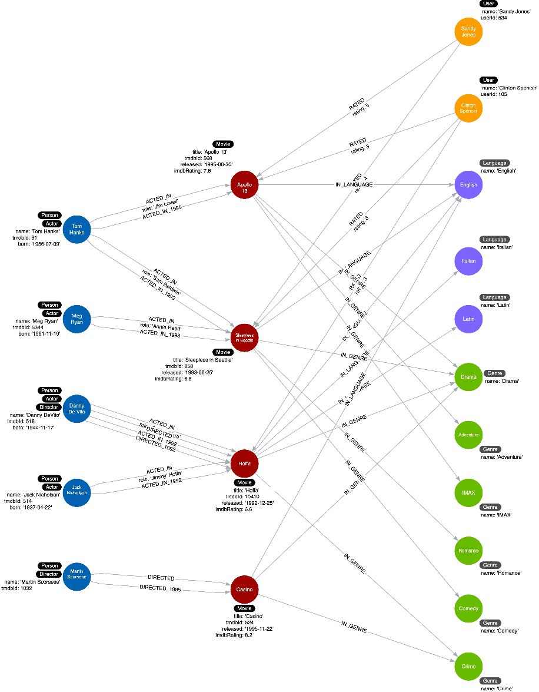

This Challenge has 2 steps:

1. [**Refactor all ACTED_IN relationships**](https://graphacademy.neo4j.com/courses/modeling-fundamentals/7-using-specific-relationships/2-c-add-actedin-types/#_refactor_all_acted_in_relationships)
2. [**Refactor all DIRECTED relationships**](https://graphacademy.neo4j.com/courses/modeling-fundamentals/7-using-specific-relationships/2-c-add-actedin-types/#_refactor_all_directed_relationships)

## **Refactor all ACTED_IN relationships**

Execute the following code to create a new set of relationships based on the year of the released property for each Node.

For example, Apollo 13 was released in 1995, so an additional ACTED_IN_1995 will be created between Apollo 13 and any actor that acted in the movie.

**cypher**

**Creating Specialized Relationships**

Copy to ClipboardRun in Sandbox

MATCH (n:Actor)-[:ACTED_IN]->(m:Movie)

CALL apoc.merge.relationship(n,

'ACTED_IN_' + left(m.released,4),

{},

{},

m ,

{}

) YIELD rel

RETURN count(*) AS `Number of relationships merged`;

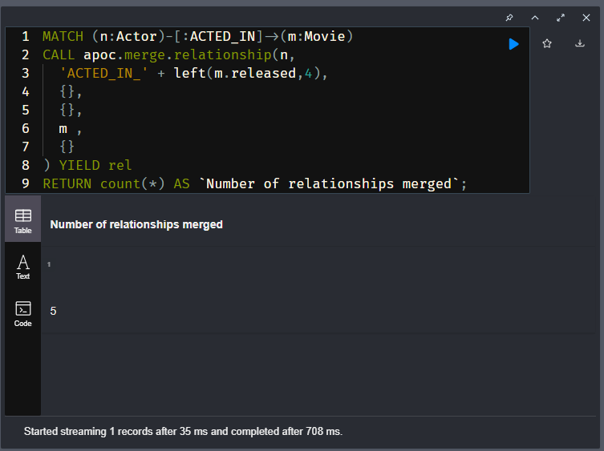

It should create 5 relationships.

With this refactoring, we can now confirm that our rewritten query works for the use case:

**Use case #12: What movies did an actor act in for a particular year?**

To verify the query has run successfully, we can attempt to use the newly created ACTED_IN_1995 relationship to see which Movies Tom Hanks acted in that were released in 1995.

**cypher**

**Tom Hanks Movies released in 1995**

Copy to ClipboardRun in Sandbox

MATCH (p:Actor)-[:ACTED_IN_1995]->(m:Movie)

WHERE p.name = 'Tom Hanks'

RETURN m.title AS Movie

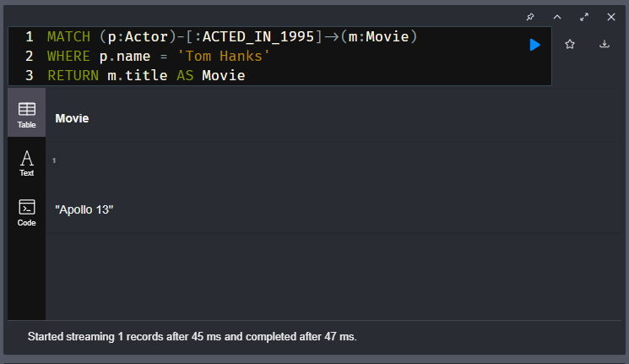

It should return one movie from our dataset, **Apollo 13**.

## **Refactor all DIRECTED relationships**

We can use the same method to create DIRECTED_{year} relationships between the Director and the Movie.

Modify the code you have just run to match the following pattern.

MATCH (n:Director)-[:DIRECTED]→(m:Movie)

Then modify the procedure call change the prefix of the relationship to DIRECTED_.

It should create 2 relationships.

MATCH (n:Director)-[:DIRECTED]->(m:Movie)

CALL apoc.merge.relationship(n,

  'DIRECTED_' + left(m.released,4),

  {},

  {},

  m ,

  {}

) YIELD rel

RETURN count(*) AS `Number of relationships merged`;

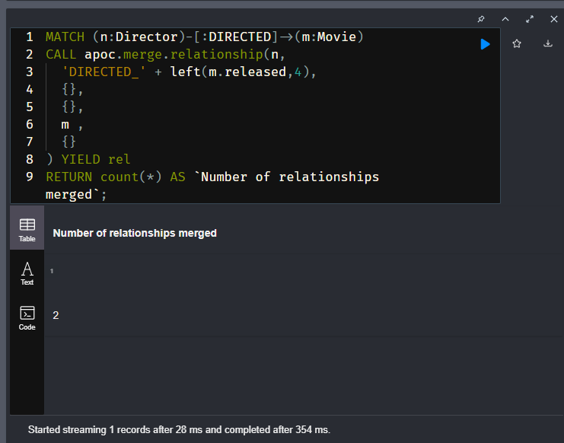

## **Testing the Model**

With this refactoring and the previous refactoring, we can now confirm that our rewritten query works for the use case:

**Use case #12: What movies did an actor act in for a particular year?**

**cypher**

Copy to ClipboardRun in Sandbox

MATCH (p:Person)-[:ACTED_IN_1995|DIRECTED_1995]->()

RETURN p.name as `Actor or Director`

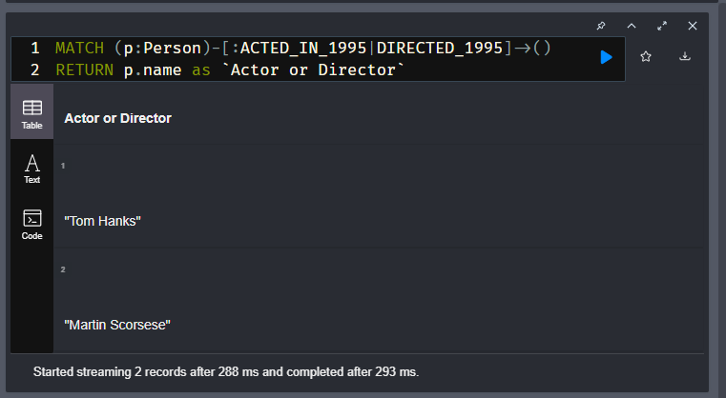

It should return Tom Hanks and Martin Scorsese.

# Specializing RATED Relationships

In the previous Challenge, you added a number of specialized relationships to the graph for the ACTED_IN and DIRECTED relationships. This Challenge has 3 steps.

In our current graph, there are RATED relationships between User nodes and Movie nodes.

Suppose we wanted to improve the performance of this query:

**Use case #9: What users gave a movie a rating of 5?**

## **Why create specialized relationships?**

Let’s take a practical example. Run this Cypher code to test this use case with the movie, Apollo 13.

**cypher**

Copy to ClipboardRun in Sandbox

MATCH (u:User)-[r:RATED]->(m:Movie)

WHERE m.title = 'Apollo 13' AND

r.rating = 5

RETURN u.name as Reviewer

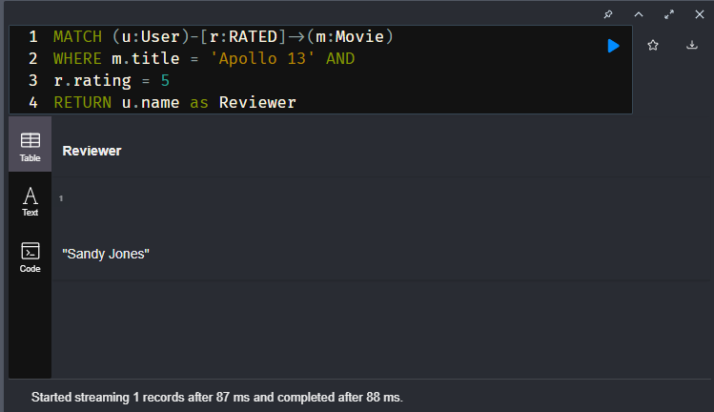

It should return one User, Sandy Jones.

What if there were thousands of Users in the graph. This query would need to traverse all RATED relationships and evaluate the rating property. For a large graph, more evaluations mean longer query processing time.

In this challenge, you will specialize the RATED relationships to reflect the rating. Unlike the refactoring where we removed the genres and languages properties from the nodes, we will not remove the rating property from the RATED relationship. This is because we may need it for a query that has a reference to the relationship and needs to return the rating value.

This is the instance model you will refactor toward:

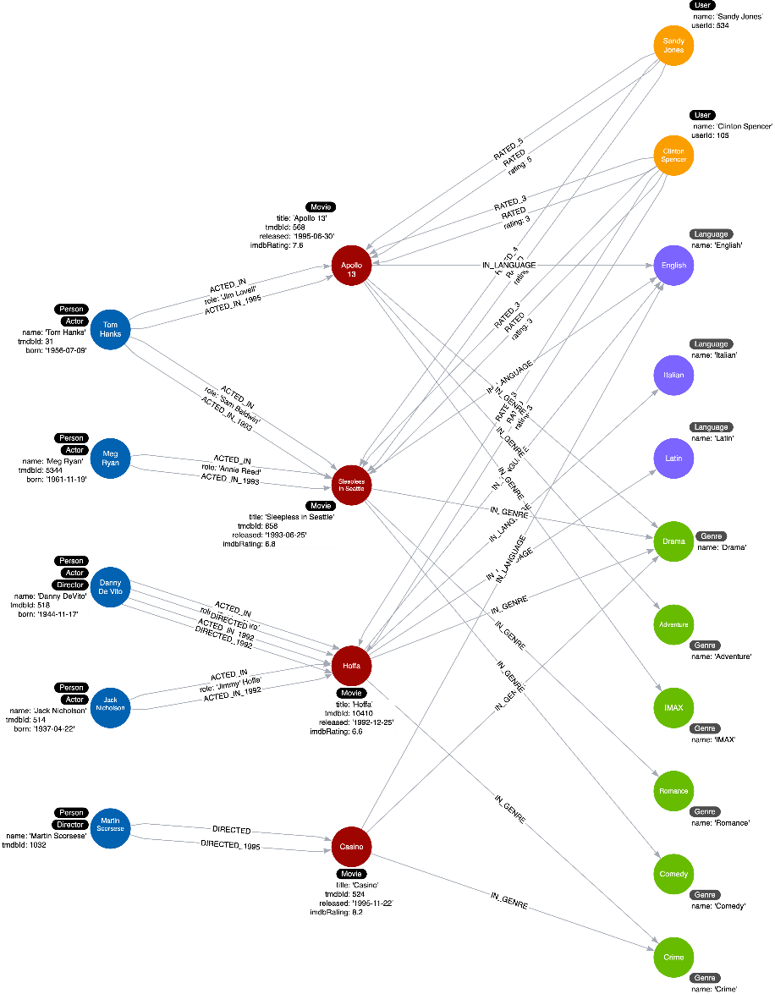

## **Creating specialized RATED_{rating} Relationships**

To pass this challenge, you must use the knowledge you gained in the previous lesson to merge a relationship between the graph using apoc.merge.relationship.

The pattern you must search for is:

*MATCH (u:User)-[r:RATED]→(m:Movie)*

The relationship type passed as the second parameter should be:

*'RATED_'+ r.rating*

// Modify this query to use the -[:RATED]->()

// relationship to  create a new RATED_{rating}

// relationship between the :User and a :Movie

MATCH (u:User)-[r:RATED]->(m:Movie)

CALL apoc.merge.relationship(u,

  'RATED_' + r.rating,

  {},

  {},

  m ,

  {}

) YIELD rel

RETURN count(*) AS `Number of relationships merged`

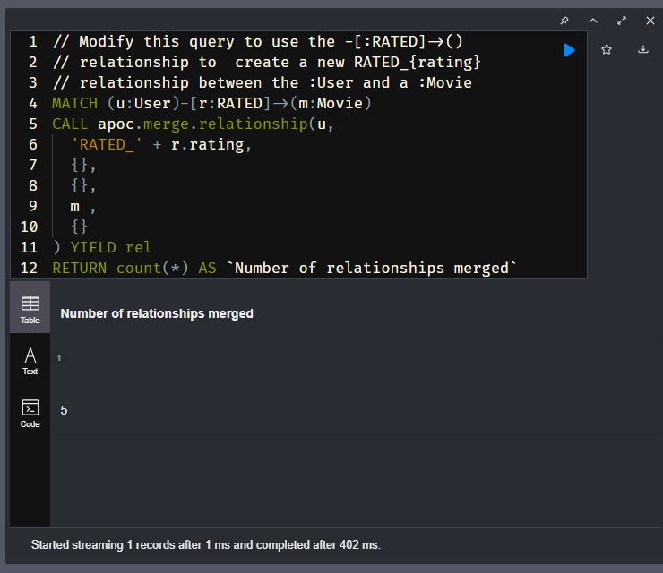

# Module 8: Adding Intermediate Nodes

## Module Overview

In this module, you will learn about:

* Why intermediate nodes are necessary.
* Creating an intermediate node.

# Intermediate Nodes

## Intermediate nodes

Youtube video: <https://youtu.be/JLFqmW9Erbw>

Transcript-

You sometimes find cases where you need to connect more data to a relationship than can be fully captured in the properties. In other words, you want a relationship that connects more than two nodes. Mathematics allows this, with the concept of a hyperedge. This is impossible in Neo4j, but a solution is to create intermediate nodes.

**You create intermediate nodes when you need to:**

* Connect more than two nodes in a single context.
  + Hyperedges (n-ary relationships)
* Relate something to a relationship.
* Share data in the graph between entities.

These three use cases are used to make the graphs relationships more meaningful and sharable between nodes.

### **Example: Need for intermediate nodes**

Here is an example instance model:



Here we have the WORKS_AT hyperedge that has the from and to properties, but we need to associate the role with this period of work. In Neo4j, there is no way to create a relationship that connects a relationship to a third node. Neo4j relationships can only connect two nodes.

#### Adding an intermediate node to the model

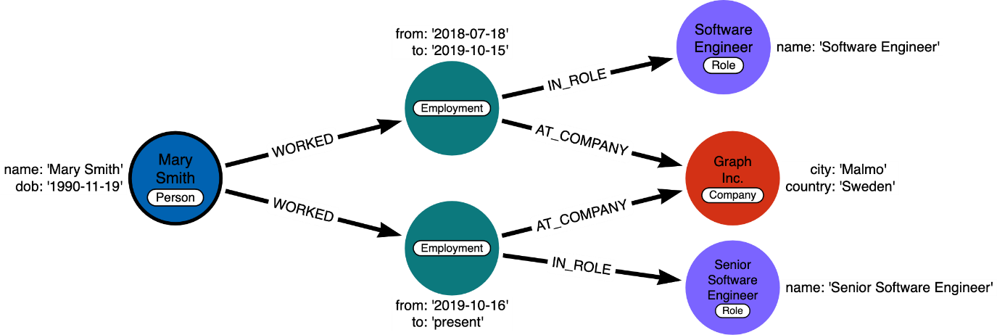

The solution is to replace the hyperedge with a connection point node. Since nodes are connection points, you simply create a node in the middle of the hyperedge.

In this example, we replace the WORKS_AT hyperedge with an Employment intermediate node. This provides a connection point that allows us to connect any amount of information to Mary’s term of employment at Acme. In addition, Person nodes can have a shared Role or Company, and allow us to very easily trace either the full details of a single person’s career, or the overlap between different individuals.

### **Example: Intermediate nodes for sharing data**

In many cases relationships can share data which enables your graph to contain less duplicate data.

Here is what the graph looks like before we refactor it:

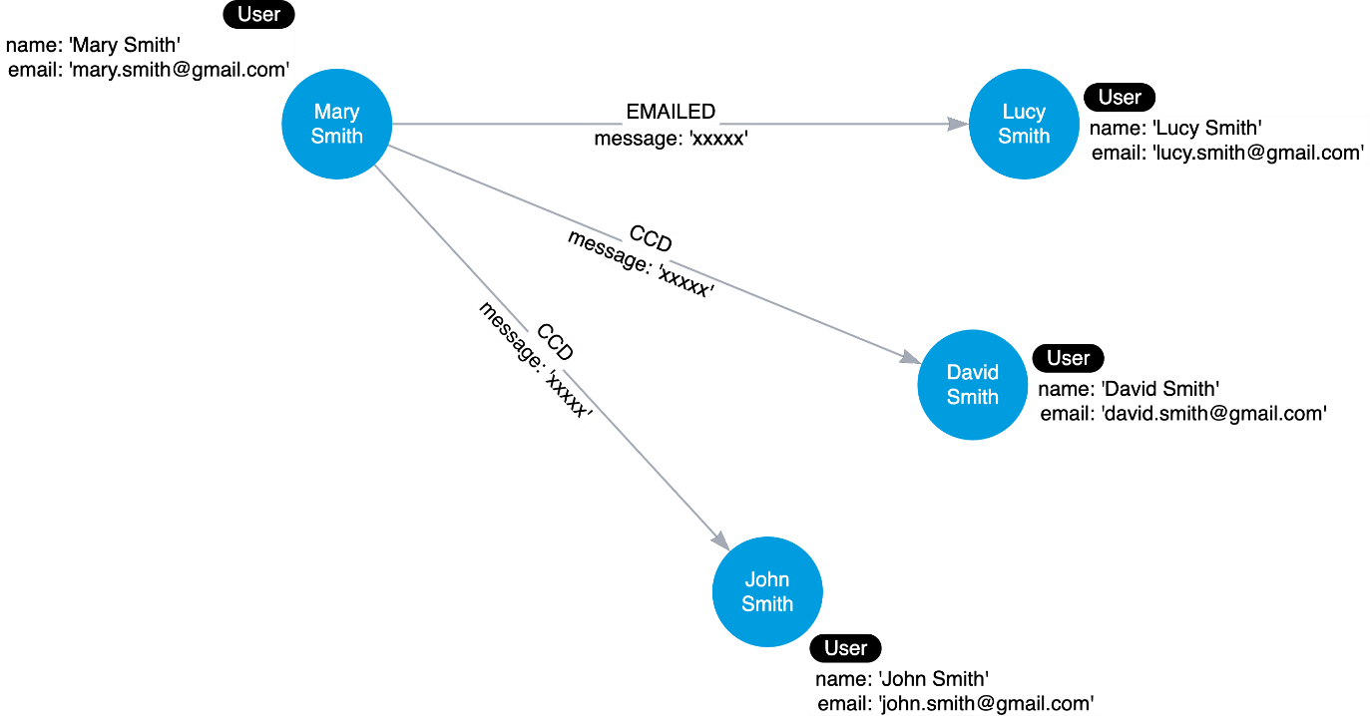

Intermediate nodes also allow you to deduplicate information. We mentioned a similar principle when we discussed fanout where splitting a property onto its own node allows you to reference it via a relationship instead of a repeated property.

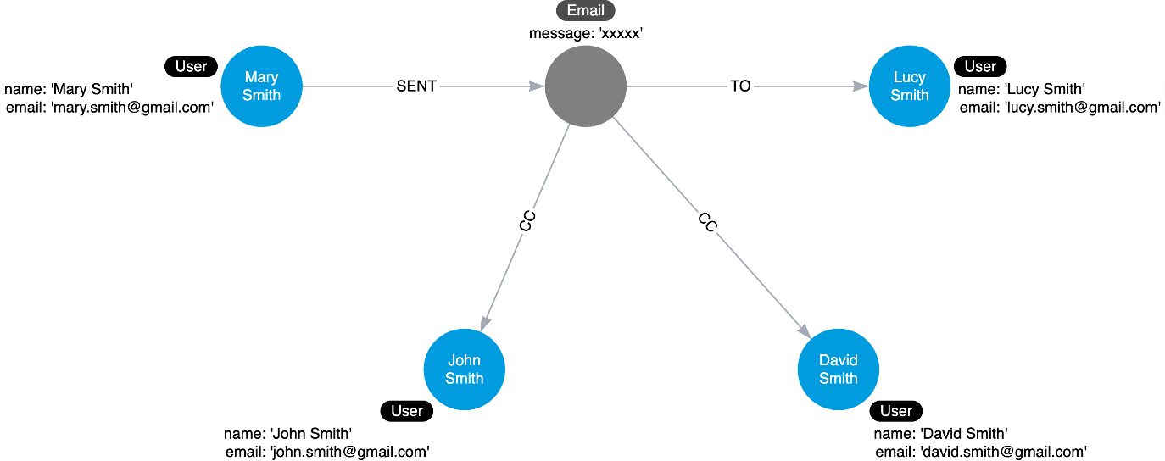

In this case, the Email intermediate node spares us having to repeat the email content on every single relationship.

### **Intermediate nodes for the movie graph?**

Here is our current instance model for the movie graph we have been working with:

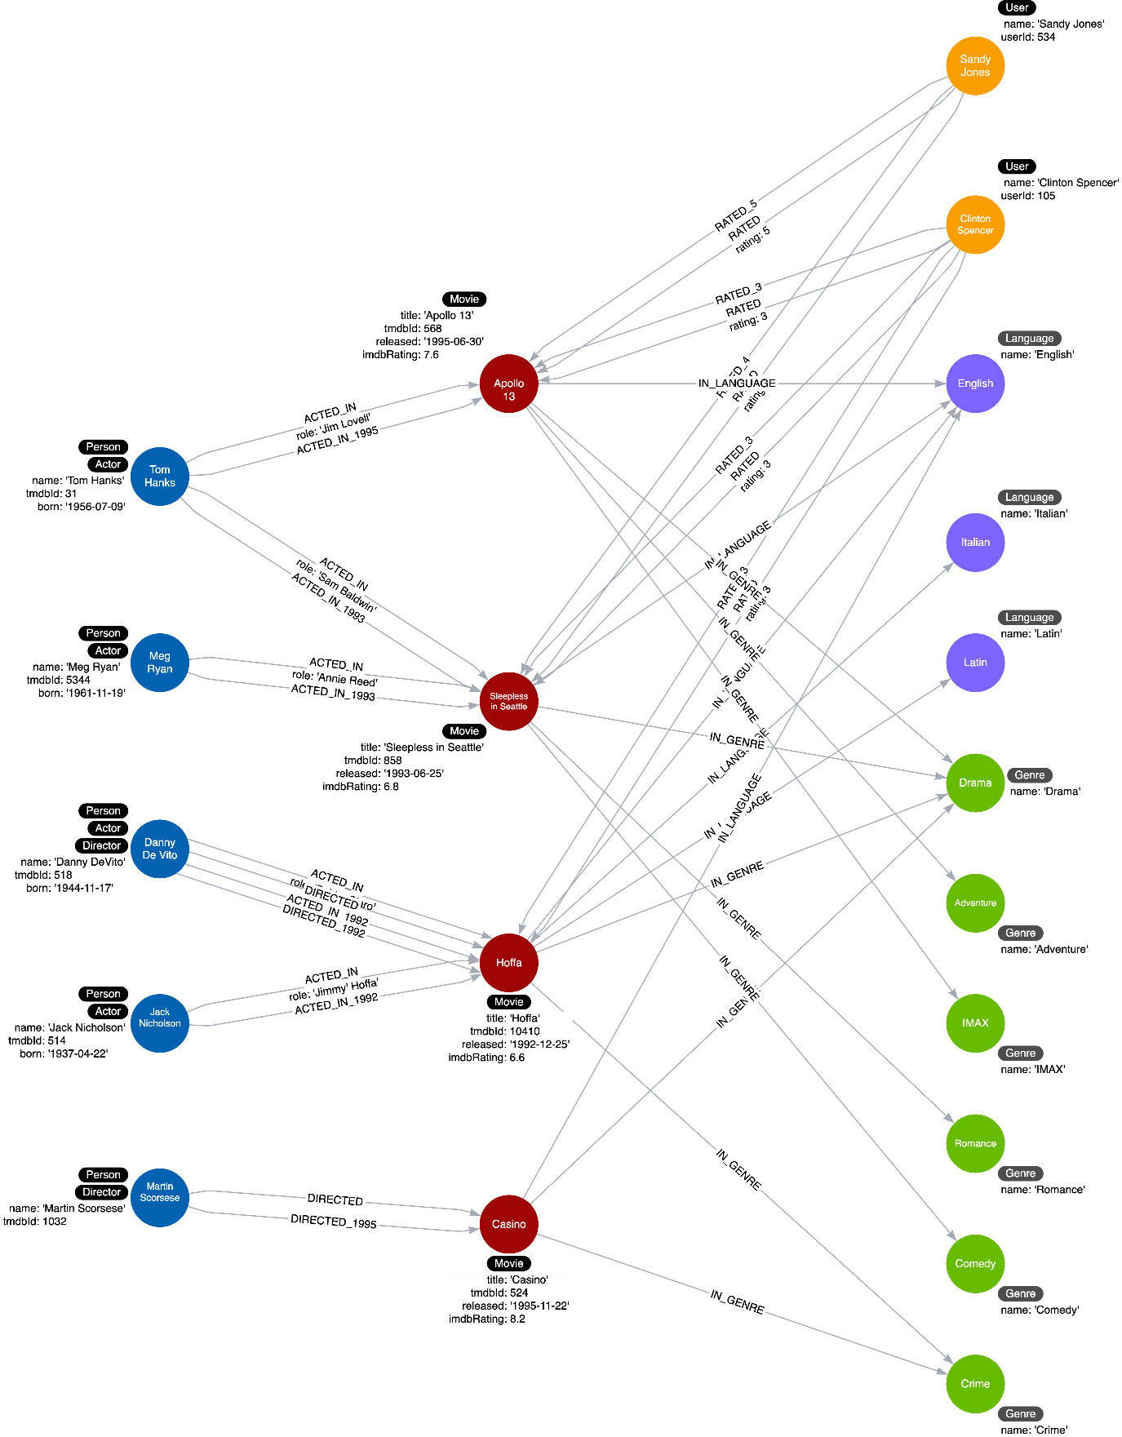

In looking at the data, we can see that if we were able to perform further analysis of the roles property of the ACTED_IN relationships, we would be able to answer questions about how the same role is used in multiple movies. Furthermore, we might want to analyze how different roles interact with each other, even across different movies.

### In Summary-

* 1. Creating intermediate nodes allows for **two or more nodes to connect in a single context**, for example, a User may rate a movie via the company’s website or mobile app.
  2. That information can also be **shared**, allowing you to query through an element that used to be siloed within a relationship.
  3. Extracting a relationship into a node is also referred to as **relating something to a relationship**.
  4. This, however, **will not reduce the number of relationships in the graph**. The size of the graph will only get bigger.

# Adding a Role Node

We want to infer more from the roles that an actor played in a movie. The same role could be repeated in multiple movies. Furthermore, we might want to add how different roles interact with each other in the same movie or between movies.

Given the current instance model:



How would you refactor the graph to add an intermediate node representing the *role* property of the *ACTED_IN* relationship?

Here is the proposed instance model:

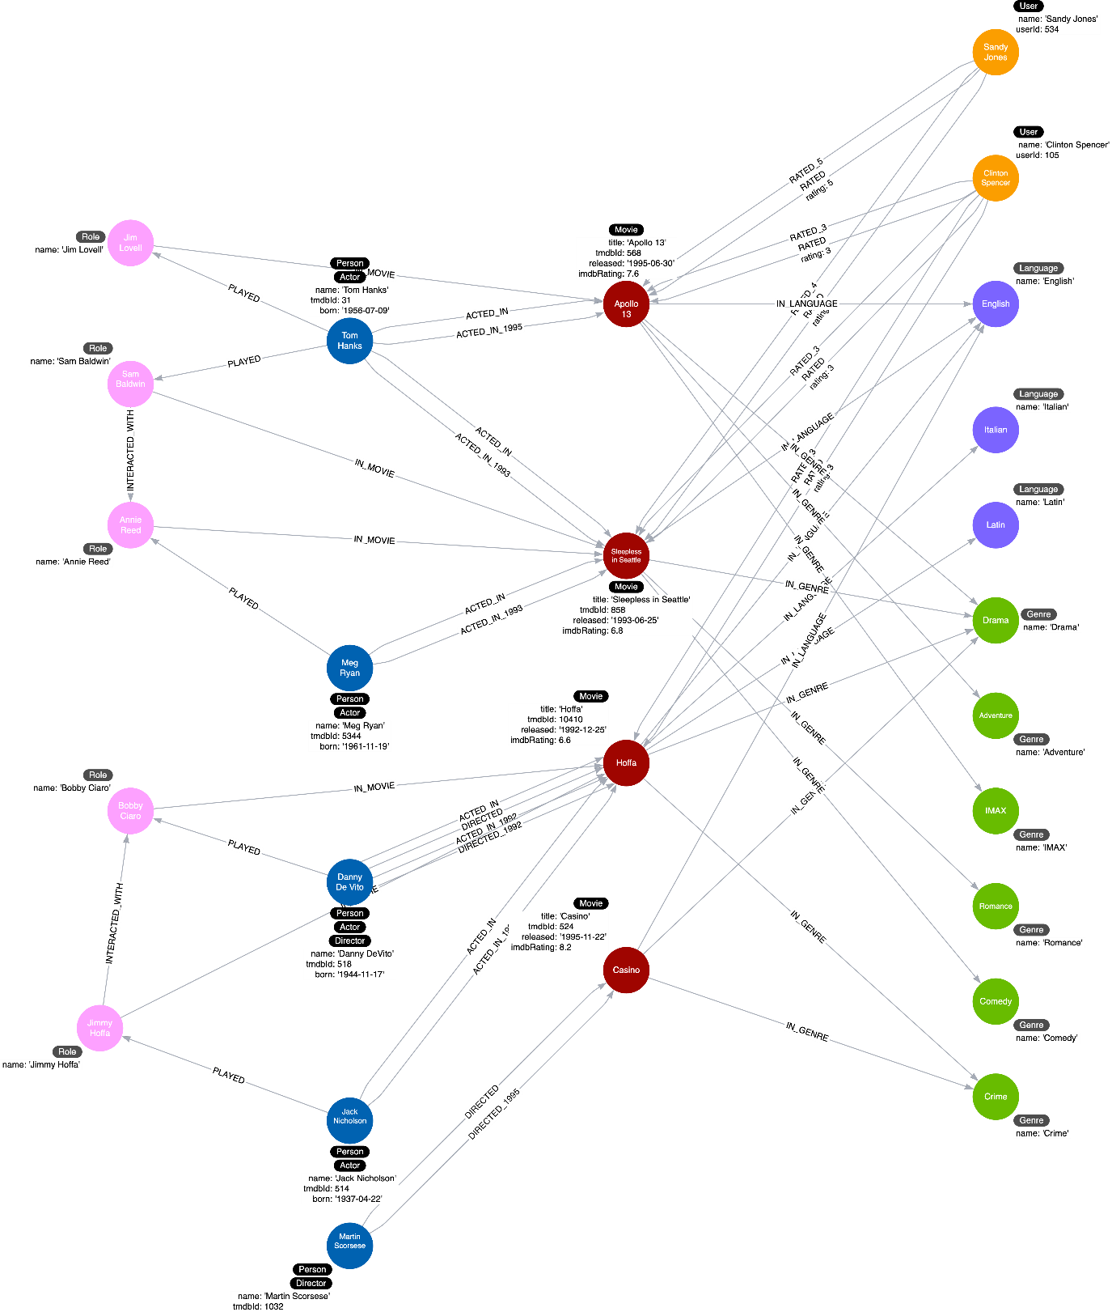

We add a *Role* node using the *role* property from the *ACTED_IN* relationship.

In this instance model we also show that some *Role* nodes could be related to each other with the *INTERACTED_WITH* relationship, but you will **not** implement the *INTERACTED_WITH* relationships.

Write and run refactor code to:

1. Find an actor that acted in a Movie (MATCH (a:Actor)-[r:ACTED_IN]→(m:Movie))
2. Create (using MERGE) a *Role* node setting it’s name to the role in the *ACTED_IN* relationship.
3. Create (using MERGE) the *PLAYED* relationship between the *Actor* and the *Role* nodes.
4. Create (using MERGE) the *IN_MOVIE* relationship between the *Role* and the *Movie* nodes.

Your code should create 5 nodes and 10 relationships.

### Solution (given and with comments)-

**cypher**

**Create Role nodes**

Copy to ClipboardRun in Sandbox

*// Find an actor that acted in a Movie*

MATCH (a:Actor)-[r:ACTED_IN]->(m:Movie)

*// Create a Role node*

MERGE (x:Role {name: r.role})

*// Create the PLAYED relationship*

*// relationship between the Actor and the Role nodes.*

MERGE (a)-[:PLAYED]->(x)

*// Create the IN_MOVIE relationship between*

*// the Role and the Movie nodes.*

MERGE (x)-[:IN_MOVIE]->(m)

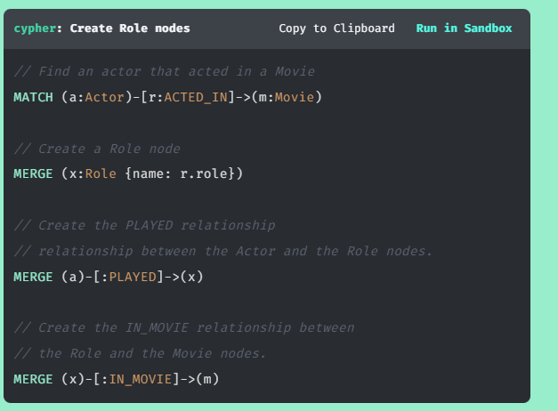

### Submitted Solution (same but without comments)-

MATCH (a:Actor)-[r:ACTED_IN]->(m:Movie)

MERGE (x:Role {name:r.role})

MERGE (a)-[:PLAYED]->(x)

MERGE (x)-[:IN_MOVIE]->(m)

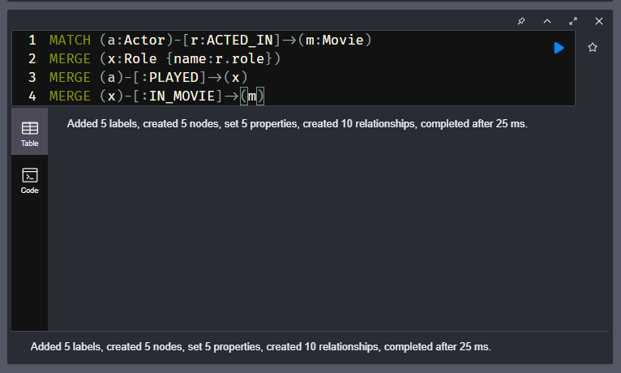

# Course Summary

In this course, you have learned how to:

* Describe what is a graph data model?
* Model nodes and create nodes for an instance model.
* Model relationships and create relationships for an instance model.
* Test the graph data model.
* Refactor a graph data model to add labels.
* Eliminate duplicate data in the graph.
* Add specific relationship types.
* Add intermediate nodes.

## Resources

* **There are many resources available to you for learning more about Neo4j**  
  [**https://neo4j.com/developer/resources/**](https://neo4j.com/developer/resources/)
* **Neo4j Community Site where you can ask or answer questions about Neo4j and discuss with other users:**  
  [**https://community.neo4j.com**](https://community.neo4j.com/)
* **Neo4j documentation:**  
  [**https://neo4j.com/docs/**](https://neo4j.com/docs/)
* **Neo4j Sandboxes for experimenting with graphs:**  
  [**https://sandbox.neo4j.com/?ref=graph-academy**](https://sandbox.neo4j.com/?ref=graph-academy)
* **Videos on the Neo4j YouTube channel:**  
  [**https://www.youtube.com/channel/UCvze3hU6OZBkB1vkhH2lH9Q**](https://www.youtube.com/channel/UCvze3hU6OZBkB1vkhH2lH9Q)
* **Become a Neo4j certified developer:**  
  [**https://graphacademy.neo4j.com/categories/certification/**](https://graphacademy.neo4j.com/categories/certification/)
* **GitHub repository:**  
  [**https://github.com/neo4j-contrib**](https://github.com/neo4j-contrib)
* **Neo4j events all over the world:**  
  [**https://neo4j.com/events/world/all/**](https://neo4j.com/events/world/all/)
* **Graph Gists for learning more use cases for Neo4j:**  
  [**https://neo4j.com/graphgists/**](https://neo4j.com/graphgists/)
* **Attend a Neo4j meetup:**  
  [**https://www.meetup.com/topics/neo4j/**](https://www.meetup.com/topics/neo4j/)
* **View questions/answers raised about Neo4j:**  
  [**https://stackoverflow.com/tags/neo4j/hot**](https://stackoverflow.com/tags/neo4j/hot)